Name: _________________ Course: ________
WATCHING THE NIGHT SKY

An object can be located on the sky globe by sighting it and then measuring the angle between the line of sight and a horizontal line. This angle is called the angle of elevation of the object. In this activity you will measure the angles of elevation and find some important and useful stars. Make sure to plan at least three observations one hour apart during a clear night.

Objectives:
- Make an improvise sky-measuring device
- Measure the angle of elevation using sighting device
- Find the North Star.
Materials:
- 1 pc nail (as weight)
- 1 ft. thread (to hang the weight)
- masking tape (to attach the straw to the protractor)
- 1 pc protractor
- 1 soda straw
- 1 push pin

Procedure
- Measuring Angles of Elevation and Finding the North Star.
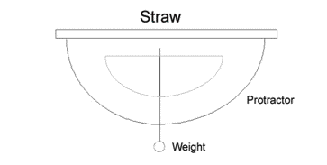
- Study the illustration below and make one for you. You will use this as your improvised device to measure the angle of elevation.
pin

thread

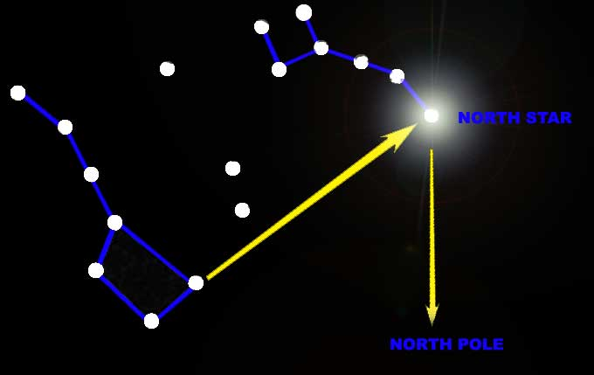
- Find the angle of elevation of the moon using your simple device and record it in the data table.
- This time, find the North Star. It is one of the useful stars for finding directions and locations on the earth. Unfortunately, it is not a very bright star and the constellation in which it is found is not always easy to pick out. Nevertheless, it is still great to try and experience the fun of locating them.
- To find the North Star, look first for the Big Dipper, a constellation that contains seven bright stars. This constellation is on your right when you face the place where the sun went down. (You may also refer to the attached evening sky map to locate the Big Dipper).
- Draw an imaginary line through the two stars at the end of the bowl of the Big Dipper (refer to the illustration from previous page). This line points to the North Star. Measure the angle of the North Star and record it in the data table as well as the angle of the two pointing stars of the Big Dipper.
Note: North Star is part of the constellation Ursa Minor (the little dipper, or also known as the little bear)
- Measure the angle of elevation of the North Star and pointing stars one hour later, two hours later and three hours later.
- Star Clock Pattern
- Refer to the attached prepared activity sheet for Star Clock Pattern. Cut-out the necessary materials and make it ready before proceeding to the next step.
- Find the Big Dipper and North Star.
- Face the North Star.
- Turn the outer circle of the Star clock so the current month is at the top.
- Turn the inner circle until the picture of the Big Dipper lines up with the Big Dipper in the night sky.
- Read the time in the window and compare it to the actual time in your watch.

Observations
- Angle of Elevations
Celestial Object | Angle of Elevation
 | 7:00 P.M. | 8:00 P.M. | 9:00 P.M. | 10:00 P.M.
Moon

North Star
Pointing star 1 (Big Dipper)
Pointing star 2 (Big Dipper)
Analysis and Conclusion
- Study the changes in elevation for each star. Which star changed its position least? Which star changed its position most?
- How many degrees did the line move in one hour? In two hours? Where would you expect to find the line at the end of six hours?
- Using your data obtained in the activity, discuss your observation with the star clock pattern.

