LESSON 6
SKELEYAL SYSTEM
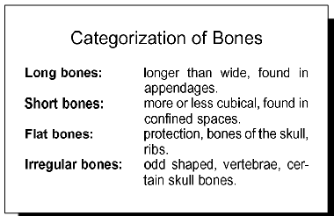
The skeletal system consists of the bones (206 in adults) and joints, along with the cartilage and ligaments that occur at the joints.

Functions of the Skeleton
The skeleton has the following functions:
- The skeleton supports the body. The bones of the lower limbs support the entire body when we are standing, and the pelvic girdle supports the abdominal cavity.
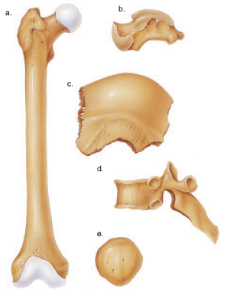
- The skeleton protects soft body parts. The bones of the skull protect the brain; the rib cage protects the heart and lungs.
- The skeleton produces blood cells. All bones in the fetus have red bone marrow that produces blood cells. In the adult, only certain bones produce blood cells.
- The skeleton stores minerals and fat. All bones have a matrix that contains calcium phosphate, a source of calcium ions and phosphate ions in the blood. Fat is stored in yellow bone marrow.
- The skeleton, along with the muscles, permits flexible body movement. While articulations (joints) occur between all the bones, we associate body movement in particular with the bones of the limbs.
Anatomy of a Long Bone
Bones are classified according to their shape. Long bones are longer than they are wide. Short bones are cube shaped—that is, their lengths and widths are about equal. Flat bones, such as those of the skull, are platelike with broad surfaces. Irregular bones have varied shapes that permit connections with other bones. Round bones are circular in shape.
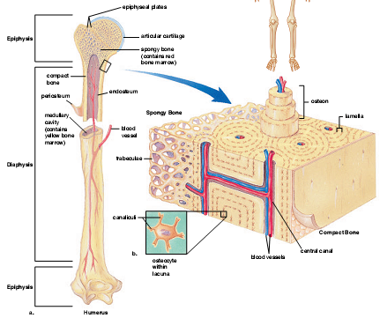
The bone is enclosed in a tough, fibrous, connective tissue covering called the periosteum, which is continuous with the ligaments and tendons that anchor bones. The periosteum contains blood vessels that enter the bone and service its cells. At both ends of a long bone is an expanded portion called an epiphysis; the portion between the epiphyses is called the diaphysis. As shown in the section of an adult bone in the illustration, the diaphysis is not solid but has a medullary cavity containing yellow marrow. Yellow marrow contains large amounts of fat. The medullary cavity is bounded at the sides by compact bone. The epiphyses contain spongy bone. Beyond the spongy bone is a thin shell of compact bone and, finally, a layer of hyaline cartilage called the articular cartilage. Articular cartilage is so named because it occurs where bones articulate (join). Articulationis the joining together of bones at a joint. The medullary cavity and the spaces of spongy bone are lined with endosteum, a thin, fibrous membrane.

Compact Bone
Compact bone, or dense bone, contains many cylinder shaped units called osteons. The osteocytes (bone cells) are in tiny chambers called lacunae that occur between concentric layers of matrix called lamellae. The matrix contains collagenous protein fibers and mineral deposits, primarily of calcium and phosphorus salts. In each osteon, the lamellae and lacunae surround a single central canal. Blood vessels and nerves from the periosteum enter the central canal. The osteocytes have extensions that extend into passageways called canaliculi, and thereby the osteocytes are connected to each other and to the central canal.
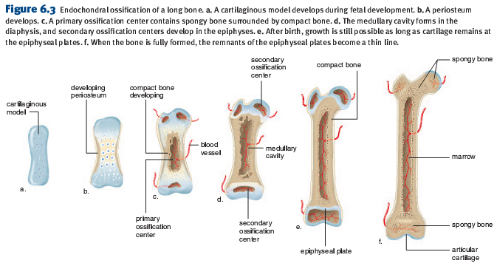
Spongy Bone
Spongy bone, or cancellous bone, contains numerous bony bars and plates, called trabeculae. Although lighter than compact bone, spongy bone is still designed for strength. Like braces used for support in buildings, the trabeculae of spongy bone follow lines of stress. In infants, red bone marrow, a specialized tissue that produces blood cells, is found in the cavities of most bones. In adults, red blood cell formation, called hematopoiesis, occurs in the spongy bone of the skull, ribs, sternum (breast-bone), and vertebrae, and in the ends of the long bones.

Bone Repair
Repair of a bone is required after it breaks, or fractures. Bone repair occurs in a series of four steps:
1. Hematoma. Within six to eight hours after a fracture, blood escapes from ruptured blood vessels and forms a hematoma (mass of clotted blood) in the space between the broken bones.
2. Fibrocartilaginous callus. Tissue repair begins, and fibrocartilage fills the space between the ends of the broken bone for about three weeks.
3. Bony callus. Osteoblasts produce trabeculae of spongy bone and convert the fibrocartilaginous callus to a bony callus that joins the broken bones together and lasts about three to four months.
4. Remodeling. Osteoblasts build new compact bone at the periphery, and osteoclasts reabsorb the spongy bone, creating a new medullary cavity.

Surface Features of Bones
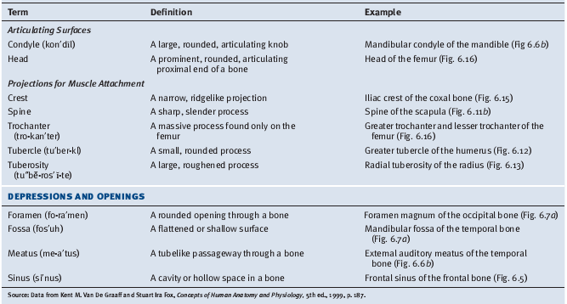

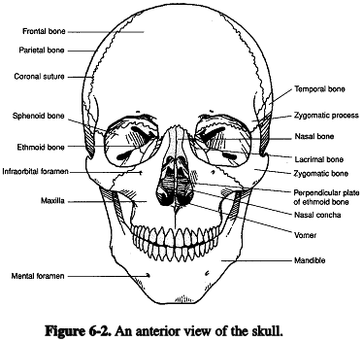
Bones of the Axial Skeleton

The skeleton is divided into the axial skeleton and the appendicular skeleton. The tissues of the axial and appendicular skeletons are bone (both compact and spongy), cartilage (hyaline, fibrocartilage, and elastic cartilage), and dense connective tissue, a type of fibrous connective tissue.

The skull is composed of 8 cranial bones that articulate firmly with one another to enclose and protect the brain and associated sense organs, and 14 facial bones that form the foundation for the face and anchor the teeth.

Frontal Bone One frontal bone forms the forehead, a portion of the nose, and the superior portions of the orbits (bonysockets of the eyes).
Parietal Bones Two parietal bones are just posterior to the frontal bone. They form the roof of the cranium and also help form its sides.
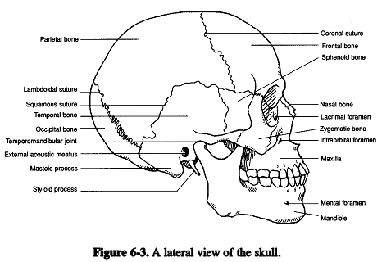
Occipital Bone One occipital bone forms the most posterior part of the skull and the base of the cranium. The spinal cord joins the brain by passing through a large opening in the occipital bone called the foramen magnum. The occipital condyles are rounded processes on either side of the foramen magnum that articulate with the first vertebra of the spinal column.
Temporal Bones Two temporal bones are just inferior to the parietal bones on the sides of the cranium. They also help form the base of the cranium. Each temporal bone has the following:
- external auditory meatus, a canal that leads to the middle ear;
- mandibular fossa, which articulates with the mandible;
- mastoid process, which provides a place of attachment for certain neck muscles;
- styloid process, which provides a place of attachment for muscles associated with the tongue and larynx;
- zygomatic process, which projects anteriorly and helps form the cheekbone.
Sphenoid Bone The sphenoid bone helps form the sides and floor of the cranium and the rear wall of the orbits. The sphenoid bone has the shape of a bat and this shape means that it articulates with and holds together the other cranial bones. Within the cranial cavity, the sphenoid bone has a saddle-shaped midportion called the sella turcica, which houses the pituitary gland in a depression.
Ethmoid Bone The ethmoid bone is anterior to the sphenoid bone and helps form the floor of the cranium. It contributes to the medial sides of the orbits and forms the roof and sides of the nasal cavity. The ethmoid bone contains the following:
- crista galli (cock’s comb), a triangular process that serves as an attachment for membranes that enclose the brain;
- cribriform plate with tiny holes that serve as passageways for nerve fibers from the olfactory receptors;
- perpendicular plate, which projects downward to form the nasal septum;
- superior and middle nasal conchae, which project toward the perpendicular plate. These projections support mucous membranes that line the nasal cavity
Bones of the Face

Maxillae The two maxillae form the upper jaw. Aside from contributing to the floors of the orbits and to the sides of the floor of the nasal cavity, each maxilla has the following
processes:
- alveolar process. The alveolar processes contain the tooth sockets for teeth: incisors, canines, premolars, and molars.
- palatine process. The left and right palatine processes form the anterior portion of the hard palate (roof of the mouth)
Palatine Bones The two palatine bones contribute to the floor and lateral wall of the nasal cavity. The horizontal plates of the palatine bones form the posterior portion
of the hard palate. Notice that the hard palate consists of (1) portions of the maxillae (i.e., the palatine processes) and (2) horizontal plates of the palatine bones. A cleft palate results when either (1) or (2) have failed to fuse.
Zygomatic Bones The two zygomatic bones form the sides of the orbits. They also contribute to the “cheekbones.” Each zygomatic bone has a temporal process. A zygomatic arch, the most prominent feature of a cheekbone consists of a temporal process connected to a zygomatic process (a portion of the temporal bone).
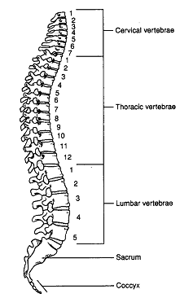
Lacrimal Bones The two small, thin lacrimal bones are located on the medial walls of the orbits. A small opening between the orbit and the nasal cavity serves as a pathway for a duct that carries tears from the eyes to the nose.
Nasal Bones The two nasal bones are small, rectangular bones that form the bridge of the nose. The ventral portion of the nose is cartilage, which explains why the nose is not seen on a skull.
Vomer Bone The vomer bone joins with the perpendicular plate of the ethmoid bone to form the nasal septum.
Inferior Nasal Conchae The two inferior nasal conchae are thin, curved bones that form a part of the inferior lateral wall of the nasal cavity. Like the superior and middle nasal conchae, they project into the nasal cavity and support the mucous membranes that line the nasal cavity.
Mandible The mandible, or lower jaw, is the only movable portion of the skull. The horseshoe-shaped front and horizontal sides of the mandible, referred to as the body, form the chin. The body has an alveolar process, which contains tooth sockets for 16 teeth. Superior to the left and right angle of the mandible are upright projections called rami. Each ramus has the following:
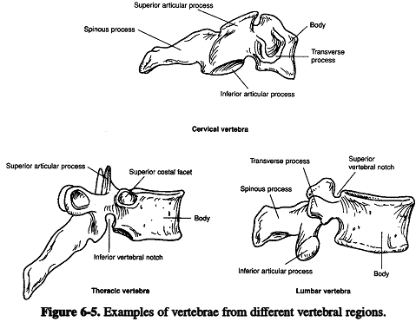
- mandibular condyle, which articulates with a temporal bone;
- coronoid process, which serves as a place of attachment for the muscles used for chewing
Hyoid Bone The U-shaped hyoid bone (Fig. 6.4) is located superior to the larynx (voice box) in the neck. It is the only bone in the body that does not articulate with another bone. Instead, it is suspended from the styloid processes of the temporal bones by the stylohyoid muscles and ligaments. It anchors the tongue and serves as the site for the attachment of several muscles associated with swallowing.
Vertebral Column Supports and permits movement of the head and trunk and provides a site for muscle attachment. The vertebrae also support and protect the spinal cord and permit the passage of spinal nerves. The first cervical vertebra (C1) is called atlas and articulates with the occipital condyle of the skull, the second cervical vertebra (C2), axis, has a peglike dens (odontoid process that provides a pivot for rotation with respect to atlas. The vertebrae are named according to their location: seven cervical (neck) vertebrae, twelve thoracic (chest) vertebrae, five lumbar (lower back) vertebrae, five sacral vertebrae fused to form the sacrum, and three to five coccygeal vertebrae fused into one coccyx. All vertebrae have a body, a neural arch composed of two supporting pedicles and two arched laminae, a vertebral foramen that allows passage of the spinal cord, spinous process, paired superior and inferior articular process and intervertebral foramen for passage of spinal nerves.
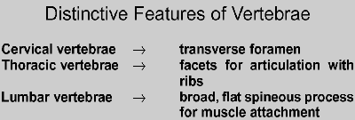
The Rib Cage
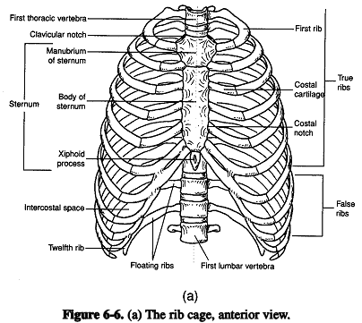
The rib cage is composed of the sternum, costal cartilages, and the ribs attached to the thoracic vertebrae. The rib cage supports the pectoral girdle and the upper extremeties, protects and supports the thoracic and upper abdominal viscera, provides an extensive surface area for muscle attachment, and plays a major role in respiration. The protions of the sternum are the manubrium, the body and the xiphoid process. Only the first 7 pairs of ribs are anchored to the sternum by individual costal cartilages, these are called the true ribs. The remaining 5 pairs of ribs are called the false ribs. Ribs 8,9 and 10 are attached to the costal cartilage of rib 7. Ribs 11 and 12 do not attach to the sternum at all and arereferred to as the floating ribs. The first 10 ribs each have a head and tuberclef or articulation with a vertebra. Ribs 11 and 12have a head but no tubercle.. all ribs have a neck, angle and shaft (body).
The Sternum
The sternum, or breastbone, is a flat bone that has the shape of a blade. The sternum, along with the ribs, helps protect the heart and lungs. During surgery the sternum may be split to allow access to the organs of the thoracic cavity.
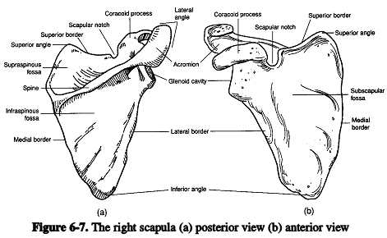
Bones of the Appendicular Skeleton
The appendicular skeleton contains the bones of the pectoral girdle, upper limbs, pelvic girdle, and lower limbs.
Pectoral Girdle
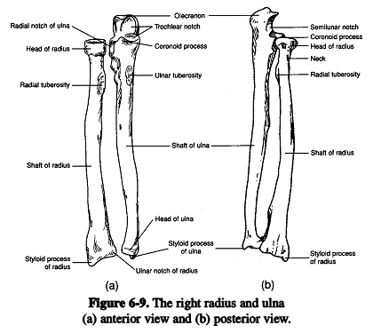
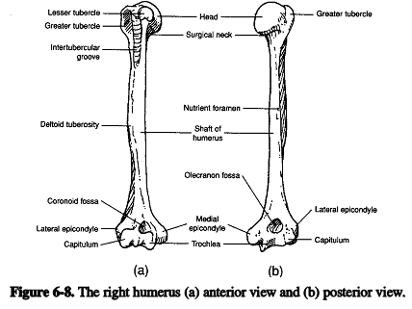
The pectoral girdle (shoulder girdle) contains four bones: two clavicles and two scapulae. It supports the arms and serves as a place of attachment for muscles that move the arms. The bones of this girdle are not held tightly together; rather, they are weakly attached and held in place by ligaments and muscles. This arrangement allows great flexibility but means that the pectoral girdle is prone to dislocation.
Clavicles
The clavicles (collarbones) are slender and S-shaped. Each clavicle articulates medially with the manubrium of the sternum. This is the only place where the pectoral girdle is attached to the axial skeleton. Each clavicle also articulates with a scapula. The clavicle serves as a brace for the scapula and helps stabilize the shoulder. It is structurally weak, however, and if undue force is applied to the shoulder, the clavicle will fracture.
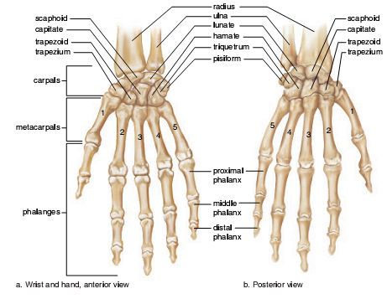
Upper Limb
The upper extremity is divided into the brachium, that contains the humerus, the antebrachium, that contains the radius and ulna; and the manus (hand) that contains 8 carpal bones, 5 metacarpal bones and 14 phalanges.
Pelvic Girdle
The pelvic girdle contains two coxal bones (hipbones), as well as the sacrum and coccyx. The strong bones of the pelvic girdle are firmly attached to one another and bear the weight of the body. The pelvis also serves as the place of attachment for the lower limbs and protects the urinary bladder, the internal reproductive organs, and a portion of the large intestine. Each coxal bone has the following three parts:
1. ilium. The ilium, the largest part of a coxal bone, flares outward to give the hip prominence. The margin of the ilium is called the iliac crest. Each ilium connects posteriorly with the sacrum at a sacroiliac joint.
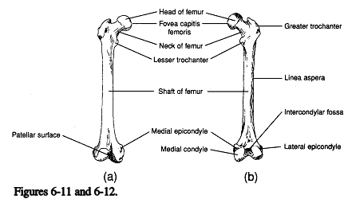
2. ischium. The ischium is the most inferior part of a coxal bone. Its posterior region, the ischial tuberosity, allows a person to sit. Near the junction of the ilium and ischium is the ischial spine, which projects into the pelvic cavity. The distance between the ischial spines tells the size of the pelvic cavity. The greater sciatic notch is the site where blood vessels and the large sciatic nerve pass posteriorly into the lower leg.
3. pubis. The pubis is the anterior part of a coxal bone. The two pubic bones join together at the pubic symphysis. Posterior to where the pubis and the ischium join together is a large opening, the obturator foramen, through which blood vessels and nerves pass anteriorly into the leg.
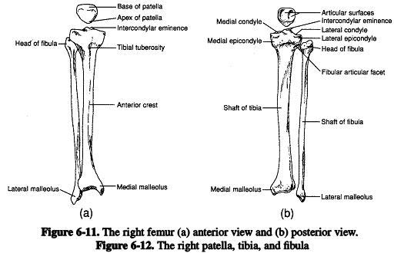
Where the three parts of each coxal bone meet is a depression called the acetabulum, which receives the rounded head of the femur.

Lower Limb
The lower limb is divided into thigh and the leg. The femur is the only bone of the thigh. The patella (kneecap) is the sesamoid bone (formed in a tendon) of the anterior knee region. The tibia and fibula are the bone of the leg. The distal end of the tibia articulates with the talus in the ankle. The features of the femur, tibia and fibula are in the illustrations.

Foot
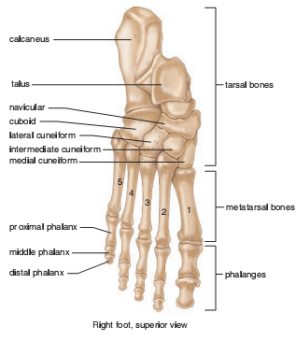
Each foot (Fig. 6.18) has an ankle, an instep, and five toes (also called digits). The ankle has seven tarsal bones; together, they are called the tarsus. Only one of the seven bones, the talus, can move freely where it joins the tibia and fibula. The largest of the ankle bones is the calcaneus,or heel bone. Along with the talus, it supports the weight of the body. The instep has five elongated metatarsal bones. The distal ends of the metatarsals form the ball of the foot. Along with the tarsals, these bones form the arches of the foot (lon-gitudinal and transverse), which give spring to a person’s step. If the ligaments and tendons holding these bones together weaken, fallen arches, or “flat feet,” can result. The toes contain the phalanges.The big toe has only two phalanges, but the other toes have three each.

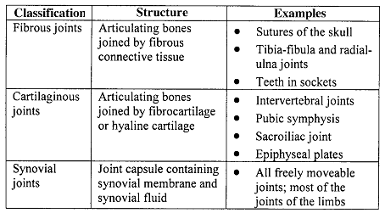
Articulations

Articulations, or joints, may be classified according to structure or function. In the structural classification, a joint is fibrous, cartilaginous, or synovial. The functional classification distinguishes synarthroses (immovable joints), amphiarthroses (slightly movable joints), and diarthroses (freely movable joints).

Types of synovial joint
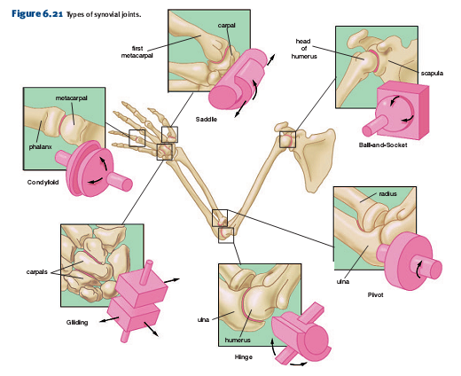
Saddle joint. Each bone is saddle-shaped and fits into the complementary regions of the other. A variety of movements are possible. Example: the joint between the carpal and metacarpal bones of the thumb.
Ball-and-socket joint. The ball-shaped head of one bone fits into the cup-shaped socket of another. Movement in all planes, as well as rotation are possible. Examples: the shoulder and hip joints.
Pivot joint. A small, cylindrical projection of one bone pivots within the ring formed of bone and ligament of another bone. Only rotation is possible. Examples: the joint between the proximal ends of the radius and ulna, and the joint between the atlas and axis.
Hinge joint. The convex surface of one bone articulates with the concave surface of another. Up-and-down motion in one plane is possible. Examples: the elbow and knee joints.
Gliding joint. Flat or slightly curved surfaces of bones articulate. Sliding or twisting in various planes is possible. Examples: the joints between the bones of the wrist and between the bones of the ankle.
Condyloid joint. The oval-shaped condyle of one bone fits into the elliptical cavity of another. Movement in different planes is possible, but rotation is not. Examples:the joints between the metacarpals and phalanges.
