REVIEWER IN SCIENCE AND TECHNOLOGY II (BIOLOGY)
Directions: Read the following questions carefully. In your answer sheet, shade the circle that corresponds to the letter of the correct answer.

- What characteristic of living things is evident when your heart beats more quickly and you breathe more rapidly after exercising?
  - irritability
  - metabolism
  - growth and development
  - maintenance of homeostasis
- Liza noticed the changes in the color of santan leaves, she hypothesized that this was due to lack of sunlight. If you were Liza, what will you do to test your hypothesis?
- gather data
- experimentation
- draw a conclusion
- identify the problem
- To which of the following does the resolution of a microscope refer?
A. Its ability to show a detail clearly
B. Its power to scan the surface of an object
- Its series of interchangeable objective lenses
- Its power to increase an object’s apparent size
- Ana, a student life scientist is examining a plant cell. If she is using a 12.5x eyepiece and a 10x objective, what is the total magnification power of the microscope?
  - 22.5x
  - 125x
  - 1.25x
  - 1,250x
- 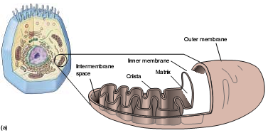Which of the following processes occurs at the pointed part of the mitochondrion?
- fixing of CO₂ to form the simple sugar.
- assembling of enzymes and other proteins.
- storing of food molecules, enzymes and other materials for the cell
- breaking down of food molecules to form an energy
- How does plant cell cytokinesis differ from the animal cell cytokinesis during telophase?
- plant cell forms cell plate
- a cleavage furrow is evident
- plant cell has a pair of centrioles moving apart
- the set of chromosome is diploid
- Which of the following characteristics of prokaryotic organisms make them different from eukaryotes?
- Prokaryotes have DNA while eukaryotes do not have.
- Prokaryotes are made of cells while eukaryotes are not.
- Eukaryotes have chromosomes while prokaryotes do not have.
- Eukaryotes have membrane-bound organelles, while prokaryotes do not have.

- Which structures listed in the box are found in plant cell but not in animal cell?
- cell wall
- centrioles
- lysosomes
- chloroplast

- 1 and 2 C. 2 and 3
- 2 and 4 D. 1 and 4
- Aling Estelita sells camote tops in the wet market. Towards noon, the camote leaves wilt. What causes the wilting of the leaves?
- decreased diffusion
- increased cell destruction
- decreased turgor pressure
- increased diffusion pressure
- What is the function of the chlorophyll during light reactions of photosynthesis?
- accepts H₂
- binds CO₂ to H₂O
- captures light energy
- acts as source of energy
- Which of the following structures is found in stems but NOT in roots?
- node
- cortex
- epidermis
- vascular tissues
- Which of the following is NOT a product of the Kreb’s cycle?
- CO₂
- ATP
- FADH₂
- ethyl alcohol
- If you subtract the two (2) adenosine triphosphate (ATP) used in the phosphorylation of glucose during glycolysis, what is the net production of ATPs after one aerobic respiration?
- 36
- 40
- 2
- 4
- Study the diagram below. Which of the following is the molecule that enters during the light phase of photosynthesis and serves as the source of oxygen for the heterotrophs?

LIGHT REACTION

DARK REACTION
sun
H H
29. __________
C₆H₁₂O₆
DIAGRAM OF PHOTOSYNTHESIS
12 H₂O
H₂O
O₂
CO₂
H₂O & C₆H₁₂O₆
- oxygen
- glucose
- carbon dioxide
- water
- Cardiac muscle ____
    - is voluntary
    - has striation
    - contracts slowly
    - lines the blood vessels
- I only
- I and II
- IV only
- II and III
- 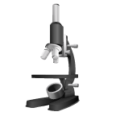Which of the following best describes the purpose of the pointed part of the figure below?
- increases the tilt of the microscope
- firmly holds the specimen in place
- facilitates the changing of the objectives
- provides approximate focusing of the low-power objective
- During what phase of the cell cycle are the chromosomes being doubled?
- G1 phase
- G2 phase
- S phase
- M phase
- Which of the following is a mismatched?
- ovary : ovulation
- uterus: implantation of the embryo
- fallopian tube : fertilization
- penis : spermatogenesis
- Which statement describes the discovery of Joseph Lister when he developed the antiseptic surgery?
- Microorganisms can cause infections
- Using sterile technique reduces the risk of infections
- Pathogens that caused certain disease can be recovered from a newly infected host.
- Pathogens must be found in the bodies of sick organisms but not in the bodies of healthy organisms.
- What is the term for the process that leads to cell specialization in multicellular organisms?
- evolution
- fertilization
- differentiation
- asexual reproduction
- All are eukaryotes EXCEPT ________.
- amoeba
- paramecium
- yeast
- cyanobacteria.
- In situation where root cells absorb nutrients from the soil, why is an active transport taken NOT passive? Because ________.
- nutrient concentration inside the cells is lower than the outside
- the nutrient concentration inside the cells is greater than the outside.
- energy is not used to move the nutrients through a permeable membrane.
- energy is used to move the nutrients through a differentially permeable membrane.
- I only
- III only
- I and III
- II and IV
- Sexual reproduction differs from asexual reproduction because it _________.
- produces new individual.
- involves the union of two identical gametes.
- produces offspring that is genetically identical with its single parent cell.
- produces offspring which is a product of combination of genes derived from the two different gametes.
- What event during meiosis is NOT evident during mitosis?
- crossing-over of chromosomes
- coiling and shortening of chromosomes
- lining up of the chromosomes at the middle of the cell
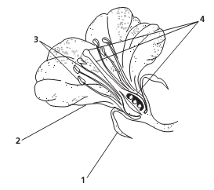
- moving of chromosomes to opposite poles
- The illustration at the right shows the four concentric whorls of a typical flower. In which whorl are the male reproductive structures found?
- 1
- 3
- 2
- 4
- Which of the following plant structures develops into a seed?
- ovary
- ovule
- anther
- stigma
- Genetic recombination in bacteria can occur during which process?
- conjugation
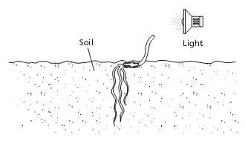
- binary fission
- endospore production
- nitrogen fixation
- The illustration at the right shows a growing seedling. Which of the following statements about the seedling is TRUE?
- The seedling is exhibiting abscission.
- The shoot is exhibiting positive phototropism.
- The roots are exhibiting negative gravitropism
- The seedling is exhibiting negative thigmotropism.
- Which of the following is used to make millions of copies of DNA pieces?
- restriction enzymes
- polymerase chain reactions
- gel electrophoresis
- gene therapy
- If a family has three daughters what is the chance that the next child will be a son?
- 50%
- 100%
- 25%
- 0%
Number 30 is about the illustration of plant cell mitosis.
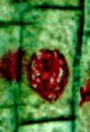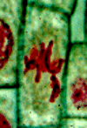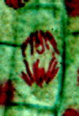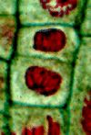

I II III IV
- Which of the following is the correct sequence?
- I, II, III, IV
- IV, III, II, I
- I,III,IV,II
- II,IV,III,I
- A person with Down’s syndrome is mildly to severely can develop mental disability. He has almond – shaped eyes with poor muscular development and coordination. Which of the following is the cause of this disorder?
- An extra X chromosome in male gametes.
- A monosomy in chromosome 21.
- A trisomy in chromosome 21.
- A trisomy in chromosome 18.
- Which of the following is NOT an example of indirect evidence of evolution?
- fossils
- embryology
- vestigial structure
- bacterial resistance to penicillin
- If Charles had the theory of “Natural Selection”, what did Lamarck have?
      - Endosymbiont theory
      - Continental drift theory
      - Principle of Use and Disuse
      - Theory of inheritance of acquired traits
    - 1 and 2 C. 1 and 3
    - 3 and 4 D. 2 and 4
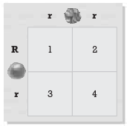
The Punnett Square below is for numbers 35 and 36. It shows the expected results of a cross between two pea plants. R and r represent the alleles for round seed and wrinkled seed traits, respectively.
- What would be the seed texture phenotype of the plant in box 4?
- Round
- Rr
- wrinkled
- rr
- What are the phenotypes of all the offspring?
- all round
- all wrinkled
- mostly wrinkled
- half round and half wrinkled
- grasses: savanna, coniferous trees : ________ .
- taiga
- tundra
- desert
- temperate deciduous forest
- Natural selection is also described as “survival of the fittest”. Which of the following measures an organism’s fitness?
- how strong it is
- its mutation rate
- how much food is it able to obtain
- how many fertile offspring it produces
- Most monocots do not have _________.
- xylem
- phloem
- primary growth
- secondary growth

- What do all arthropods have in common?
- spiracles
- antennae
- a cephalothorax
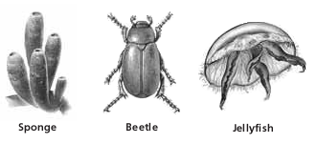
- jointed appendages
- Refer to the illustration at the right. Which of the organisms has radial symmetry?
- beetle
- sponge
- jellyfish
- both the beetle and the sponge
- What special instrument is placed inside the heart and used as impulse generator to make it functions normally?
- endoscope
- laser beam
- stethoscope
- artificial pacemaker
- An energy pyramid is a diagram that compares the amount of energy available at each position or level in the feeding order in a community. In the given illustration below, which statement is TRUE?
- 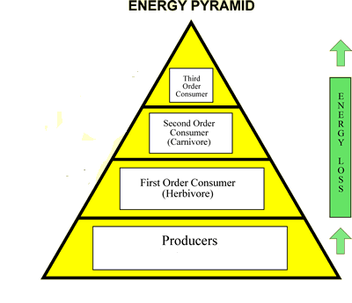Level 4 contains the most energy and is made up of producers.
4
3
2
1
- Level 1 contains the most energy and is made up of producers.
- Level 4 contains the least energy and is made up of producers.
- Level 1 contains the most energy and is made up of consumers.
For numbers 44 and 45, please refer to the graph below.
- What happens after food is eaten? Blood glucose levels ___________.
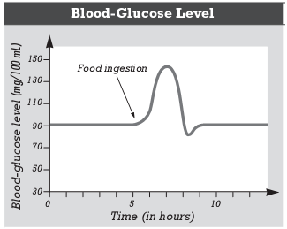
- increase
- decrease
- remain the same
- decrease and then increase
- Which hormone is primarily responsible for the changes in blood glucose levels about 2 hours after food is eaten?
- insulin
- melatonin
- thymosin
- parathyroid
- A geneticist working with the fruit fly Drosophila melonogaster discovers a mutant phenotype that appears only in males who are offspring of males of the same phenotype. What does this information suggest about the mutant phenotype?
- The trait is X-linked.
- The trait is Y-linked.
- The trait is autosomal dominant.
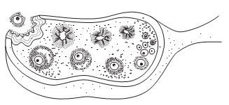
- The trait is autosomal recessive
- What event is illustrated by the figure at the right?
- ovulation
- fertilization
- menstruation
- ligation
- Which of the following would you expect to find in or on cells whose main function is absorption?
- cilia
- gap junctions
- secretory vesicles
- microvilli
- By the end of the first trimester, which of the following has occurred in the fetus?
- The fetus has a full head of hair.
- The fetus uses its lungs to breathe.
- The brain of the fetus is fully developed.
- All of the organs of the fetus have begun to form.
- Assume that three sets of these triplets in a strand of DNA are arranged as CGT-ACG-AAA. Which of the following shows the correct transcription?
- GCA-UGC-AAA
- GCA-UGC-TTT
- GCA-UGC-UUU
- CGA-GUA-UUU
- Which of the following is TRUE about the cerebral cortex? It is ___________.
- located deep in the brain.
- the folded outer covering of the brain.
- part of the peripheral nervous system.
- the lobed, highly folded structure located at the back of the brain
- A mother with blood type I^{B}i and a father with blood type I^{A}I^{B} have 4 children. Which of these is NOT a possible blood type of their children?
- AB
- B
- A
- O
- Which structure DOES NOT contain smooth muscle?
- vein
- heart
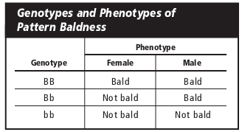
- esophagus
- artery
- Study the chart of the genotypes and phenotypes of pattern baldness at the right. Which of the following statements best explains why men and women express the Bb genotype differently?
- The trait is polygenic.
- The trait has multiple alleles.
- Pattern of baldness is a sex-linked trait.
- Pattern baldness is a sex-influenced trait.
- Which of the following exhibits external fertilization and external development of young?
- chicken
- frog
- cow
- cat

- Amity and her father loved to find the constellations in the sky on starry nights. One evening, Amity came running into the house and whispered excitedly to her mother. “Mom I’ve got power! When I look hard at a star it disappears”. If you are the mother, to what structure you will refer your explanation?
- lens
- pupil
- optic disc
- cornea
- Maria was on her first stage of labor for 15 hours. She experienced progressive uterine contractions. Which of the following hormones is the possible reason for the uterine contraction?
- glucagon.
- oxytocin.
- insulin
- epinephrine
- What is the purpose of a lizard’s ability to lose its tail and grow a new one?
- to capture prey
- to hide from predators
- to escape from predators
- to reduce its need for food
- Which of the following is a parasite?
- a lion hunting a zebra
- a deer grazing on grass
- a tick sucking blood from a dog
- a snake swallowing a bird’s egg
- Which of the following is the role of the coral reef?
- breakwater
- source of corals
- tourist attraction
- nursery for young marine species
- Which of the following is an example of a managed ecosystem?
- a forest
- the seashore
- banana plantation
- a volcano crater
- Which of the following procedures refers to determining of the genotype of the unknown individual through crossing the unknown genotype with a homozygous recessive individual?
- monohybrid cross
- dihybrid cross
- hybrid cross
- test cross
- When you cross two heterozygous parents (Pp), what will be the expected genotypes of the offspring?
    - 1 PP : 2 Pp : 1 pp
    - 1 pp : 3 PP
    - 3 Pp :1 pp
    - all Pp
- Which of the following is an example of a genotype of a heterozygous individual?
- p
- Rr
- ww
- YY
- During which process does crossing-over occur?
- mitosis
- meiosis I
- meiosis II
- interphase
- Which structure contributes to support and movement within a cell?
- microfilament
- cell wall
- golgi apparatus
- endoplasmic reticulum
- If the half-life of carbon-14 is 5,730 years, how many years would it take for 1/8 of the original amount of carbon-14 in sample decay?
- 5,014 years
- 11,460 years
- 17,190 years
- 22,920 years
- What is the term for the total genetic information in a population?
- gene pool
- allele frequency
- distribution of traits
- phenotype frequency
- How do mutations affect genetic equilibrium? Mutations ___________.
- cause emigration.
- cause immigration.
- introduce new alleles.
- maintain genotype frequency.
- To which level of classification does a group of closely related species of organisms belong?
- class.
- order
- genus
- family
- Flagella are characteristic of members of which phylum?
- mastigophora
- ciliophora
- sarcodina
- sporozoa
- Which of the following causes red tide?
- dinoflagellate
- diatoms
- euglena
- amoeba
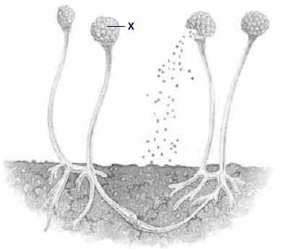
- To what phylum does the fungus in the illustration belong?
- imperfecti
- zygomycota
- basidiomycota
- ascomycota
- Which of the following phrases describes monocots?
- bear seeds in cones
- have parallel venation
- do not produce flowers
- have vascular bundles arranged in a circle
- Which are atracheophytes?
- ferns and cycads
- hornworts and liverworts
- conifers and ginkgoes
- horsetails and club mosses
- Which is NOT a characteristic of cnidarians?
- tentacles
- collar cells
- nematocysts
- digestive cavity
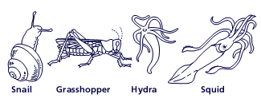
- Refer to the illustration below. Which is an example of a cephalopod mollusk?
- snail
- hydra
- grasshopper
- squid
- Some organelles have their own DNA that is distinct from the cell’s nuclear DNA. This is true of which organelle?
- cell wall
- mitochondrion
- plasma membrane
- vacuole
- Pollen in plants is most similar to which type of cell in humans?
- egg
- embryo
- sperm
- zygote
- Before a cell goes through either mitosis or meiosis, which process must be carried out by the DNA in the nucleus?
- replication
- nondisjunction
- transcription
- translation
- Several mating between the same male black guinea pig and female brown guinea pig produce a total of 12 brown and 14 black guinea pigs. If black is dominant and brown is recessive, what are the genotypes of the parents?
- BB x bb
- Bb x bb
- BB x Bb
- Bb x Bb
- Most sex-linked traits are due to recessive alleles and it includes hemophilia and color blindness that frequently appear in males. This phenomenon is BEST explained by which statement?
- Males have an X chromosome with dominant genes.
- Most of the genes on the X and Y chromosomes of males are recessive.
- In males, the recessive sex-linked genes appear only on the Y chromosome
- In males, the Y chromosome lacks the genes needed to mask the recessive genes on the X chromosome.

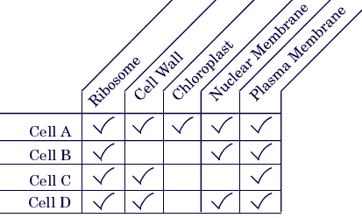
- Study the chart below. Which of the cells characterized in the chart is a prokaryotic cell?
- cell A
- cell B
- cell C
- cell D
- An organism is eukaryotic, multicellular, heterotrophic and has a cell wall. To which kingdom does it belong?
- animal
- fungi
- plant
- protist
- Bacteria living in nodules on the roots of legumes have the ability to fix atmospheric nitrogen into a water-soluble form that plants can use. The bacteria absorb sugar from the plants’ roots. Which describes the relationship between the bacteria and the legume plants?
- commensalism
- mutualism
- parasitism
- predation
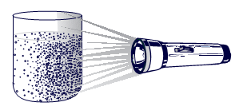
- Euglenas are one-celled organisms containing chlorophyll. A culture of Euglena is placed into a beaker in a dark room with a flashlight shining on one side, as shown in the illustration at the right. After some period of time, the Euglena gathered on one side of the beaker. What can be inferred about Euglena from this experiment?
- Euglenas show a positive response to light.
- Euglenas show a positive response to darkness
- Euglenas show a negative response to light.
- Euglenas do not react to light.
- In a forest ecosystem, which is an abiotic factor?
- the amount of rainfall
- the size of the deer
- the type of trees
- the number of birds
- Recent climate data suggests a global warming trend. The most likely cause could be an increase in which gas?
- oxygen
- carbon dioxide
- nitrogen
- hydrogen sulfide
- Some flowers show incomplete dominance. If RR = white and R’R’ = red, which phenotypic ratio would be expected in the offspring of two pink flowers?
- 1 red : 2 pink : 1 white
- 0 red : 4 pink : 0 white
- 3 red : 0 pink : 1 white
- 4 red : 0 pink : 0 white

- A couple has five children, all with blood type A. the mother’s blood type is O, and the father’s blood type is A. Based on this information, which describes the most probable genotype of the father?
- diploid
- haploid
- heterozygous
- homozygous
- Which is responsible for most genotypic and phenotypic variation among humans?
- meiosis
- budding
- mitosis
- regeneration
- Huntington’s disease is a dominant trait. What are the chances that a child will develop Huntington’s disease if one parent is heterozygous and the other is normal?
- 0 out of 4
- 1 out of 4
- 2 out of 4
- 3 out of 4
- A paleontologist is comparing the fossilized remains of two primates. Both animals had a prehensile tail. What can be concluded from this evidence?
- They were not related.
- They lived on the ground.
- They evolved from a common ancestor.
- They had a bipedal locomotion.
- Which is the BEST evidence of an evolutionary relationship between two organisms?
- similarity in behavior
- similarity in DNA
- similarity in habitat
- similarity in niche
- Which of the following is NOT a function of the epithelial tissues?
- secretion
- covering
- support
- absorption
- Which of the following refers to the red blood cell formation?
- hematopoiesis
- keratinization
- ossification
- 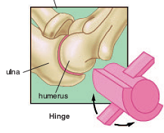cell division

- What type of synovial joint is illustrated in the figure at the right?
- pivot
- ball-and-socket

- Hinge
- gliding
- All are functions of the skeletal system EXCEPT _________.
- protects delicate organs
- stores minerals and fat
- produces blood cells
- makes vitamin D to store calcium

- Most skeletal muscles are attached to bones via _____.
- ligaments
- joints
- flexors
- tendons
- Which of the following processes refers to the engulfing of extracellular fluid by cells?
- phagocytosis
- pinocytosis
- exocytosis
- plasmolysis
- Which process of the heart supplies oxygen-rich and nutrient-rich blood to all the body organs?
- coronary circulation
- pulmonary circulation
- systemic circulation
- none of the above
- All are functions of the blood EXCEPT ________.
- defense against pathogens
- regulates body pH and temperature
- prevents blood loss during clotting
- regulates blood glucose level
- Which of the following types of white blood cells increases in number in the event of parasitic worm infection?
- eosinophil
- basophil
- monocyte
- neutrophil
- What substance found in red blood cells is responsible for oxygen transport?
- immunoglobulin
- Rh
- hemoglobin
- antibodies
- Which of the following best explains why the blood type O is considered as the universal donor? Because blood type O has __________.
- no antigens on the red blood cells
- no antibodies
- no antibodies and antigens
- both antibodies and antigens
- A heartbeat produces the familiar “lubb-dupp” sounds (Korotkoff sounds) as the chambers contract and the valves close. When the valves are defective, swishing sounds may be heard and it is called heart murmurs. Imagine that you are a health professional in a clinic. Using a sthetoscope you hear a “lubb-swish-dupp” sounds. What valves are most probably ineffective in closing the chambers?
A. atrioventricular valves
B. pulmonary semilunar valve
C. aortic semilunar valve
D. sinoatrial node
- What happens to the positions of the diaphragm when the lungs are in normal inspiration?
A. relaxes and moves inferiorly
B. relaxes and moves superiorly
C. contracts and moves superiorly
D. contracts and moves inferiorly
- What happens to the intrapulmonary volume and pressure when inspiratory muscles contract?
A. volume increases and pressure increases
B. volume decreases and pressure decreases
C. volume increases and pressure decreases
D. volume decreases and pressure increases
- Which of the following structures filters, warms, and moistens the air during pulmonary ventilation?
A. bronchi
B. trachea
C. nasal cavity
D. larynx
- All of the following hormones are involved in the menstrual cycle EXCEPT:
A. estrogen
B. progesterone
C. prolactin
D. follicle-stimulating hormone
- Which part of the compound microscope you should manipulate FIRST to make sure that the field of view has sufficient light?
A. fine adjustment knob
B. diaphragm
C. high-powered objective
D. eyepiece
- If you want to examine a cell under the compound microscope to determine if it is a prokaryote or a eukaryote, which structure in the cell will be your basis for saying that it is a eukaryote?
A. ribosome
B. nucleus
C. cell wall
D. vacuole
For number 113, please refer to the diagram below about the summary equation that explains aerobic respiration.

- Which is responsible for the release of energy stored in food?
A. carbon dioxide
B. oxygen
C. sugar
D. water
- Which of the following is TRUE about the dermis? It _________.
A. is the top layer of skin
B. is made up of dead cells
C. contains cardiac muscle
D. contains nerves and blood vessels
- In what direction does blood move during ventricular systole? From the ________.
A. atria to the veins
B. ventricles to the atria
C. atria to the ventricles
D. ventricles to the arteries
- Which of the following is the function of the fibrin?
A. transports oxygen
B. helps form a blood clot
C. destroys invading microorganisms
D. stimulates the production of antibodies
- What is the importance of epiglottis?
A. It regulates the flow of chyme
B. It avoids food from going down to the trachea
C. It separates the pharynx from the nasal cavity
D. It is the passage through which food travels to the stomach
- Which of the following is the process that takes place as a zygote begins to divide after fertilization?
A. meiosis
B. cleavage
C. gastrulation
D. organogenesis
- Which animals DO NOT have true tissues?
A. sponges
B. coelenterates
C. flat worms
D. reptiles
- What do you call the basic tissues types of an embryo?
A. coeloms
B. germ layers
C. notochords
D. pharyngeal pouches
- Why are spongin and spicules important to a sponge?
A. they digest food
B. they remove wastes
C. they provide support
D. they produce offspring
- What is the function of the tapeworm’s scolex?
A. for reproduction
B. for attachment to its host
C. for elimination of excess water
D. for guiding food into its mouth
- How do mites and ticks differ from spiders? Mites and ticks have ________.
A. mandibles
B. two pairs of antennae
C. a unique respiratory system
D. a fused cephalothorax and abdomen
- Which of the following terms refers to the immature form of an insect that undergoes incomplete metamorphosis?
A. adult
B. infant
C. pupa
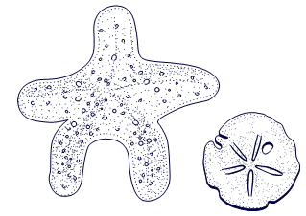
D. nymph
- To which phylum do the animals at the right belong?
A. chordata
B. vertebrata
C. arthropoda
D. echinodermata
- Which of the following characteristics is limited only to mammals?
A. produce milk for the young
B. four-chambered heart
C. bony skeleton
D. with lungs
- What term refers to the study of tissues?
A. histology
B. cytology
C. physiology
D. anatomy
- Which of the following is responsible for covering the outer layer of a visceral organ?
A. connective tissue
B. epithelial tissue
C. muscular tissue
D. nervous tissue
- What structure of the vertebrae serves as cushion and shock absorber when you jump, walk and run?
A. bursa
B. interstitial fluid
C. tendon sheath
D. intervertebral disc
- Which of the following combined function is most involved when a boy swims, frog leaps and bird flies?
A. bones and nerves
B. nerves and muscles
C. muscles and bones
D. blood and muscles
- Which of the following is the filtering unit of the kidney?
A. renal artery
B. nephron
C. Bowman’s capsule
D. loop of Henle
- Sperm mature in the ____________.
A. epididymis
B. penis
C. testes
D. vas deferens
- Meiosis is a type of cell division that produces only one set of chromosomes called monoploid or haploid. Which of the following cells undergoes meiotic cell division?
A. red blood cell
B. osteocyte
C. sperm cell
D. neuron
- Which is NOT TRUE about AIDS?
A. lesions appear on the patient
B. it attacks the immune system
C. it can be transmitted by means of socialization
D. it causes the patient’s resistance level to decline
- Which of the following animals exhibits external fertilization and external development of young?
A. frog
B. bird
C. dog
D. horse
- What part of the cell is for synthesizing proteins?
A. mitochondrion
B. chloroplast
C. ribosome
D. lysosome
- Which is the power-house of the cell?
A. mitochondrion
B. chloroplast
C. ribosome
D. lysosome
- Which of the following is a group of cells that are similar in structure and function?
A. cell
B. tissue
C. organ
D. organ system
- Which of the following refers to the shrinkage of the cytoplasm due to outward diffusion?
A. plasmolysis
B. cytolysis
C. phagocytosis
D. pinocytosis
- What is the possible effect if a cell membrane is permeable?
A. passage of materials will be controlled
B. cell will swell
C. all of the materials can easily get in and out of the cell
D. the cell will shrink
- Which of the following refers to the stage of cellular respiration that breaks down the substrate glucose into pyruvic acid?
A. glycolysis
B. acetyl Co-A formation
C. Kreb’s cycle
D. electron transport system
- Which of the following does NOT occur during interphase?
A. excretion of wastes
B. cell repair
C. protein synthesis
D. nuclear division
- An organism that contains functional recombinant DNA is called _________.
A. transgenic
B. cloned
C. mutant
D. spliced
- DNA can be prepared for recombination only after it has been isolated and snipped into smaller fragments. The discovery in the early 1970’s of DNA-cleaving enzymes made such cutting possible. Which of the following bacterial proteins cut both strands of DNA?
A. restriction enzymes
B. transgenic vectors
C. recombinant enzymes
D. recombinant DNA
- Analyze the karyotype at the right, which of the following genetic disorders is shown in the illustration?
A. Patau’s syndrome
B. Down’s syndrome
C. Klinefelters syndrome
D. Turner’s syndrome
- Which of the following is the special connective tissue that composes your ears and nose?
A. tendons
B. ligament
C. cartilage
D. blood
- Which of the following is the main difference between bird and reptile reproduction?
A. birds lay eggs
B. reptiles lay eggs
C. reptiles have internal fertilization
D. most birds take care of their young
- Which of the following is the structure that acts as pump and regulates excess water in the cell of a paramecium?
A. contractile vacuole
B. food vacuole
C. oral groove
D. cilia
- Which of the following is the ability of organisms to form new parts?
A. autotomy
B. regeneration
C. mimicry
D. replication
- The figure below shows the embryonic development of fish, reptile, bird and human. What can be inferred in the illustration?
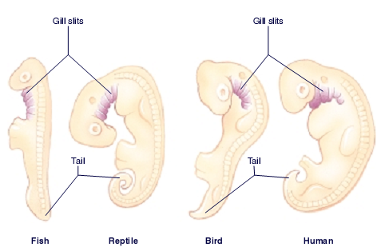
A. They look more similar as development progresses.
B. They have different gestation period.
C. They evolved from a common ancestor.
D. They evolved from different ancestors
- Which of the following DOES NOT describe fungi?
A. some have mutual relationship with other organisms
B. they obtain food from decayed matters
C. they are photosynthetic organisms
D. they are parasites
- Which of the following is for bacterial reproduction?
A. budding
B. regeneration
C. binary fission
D. mutation
- In what stage of the interphase does the replica of genome being synthesized?
A. S phase
B. G₁ phase
C. G₂ phase
D. mitosis
- Which branch of biology deals with the classifying, grouping and naming of living things?
A. genetics
B. taxonomy
C. entomology
D. zoology
- Which is a correct way of writing the scientific name?
A. Homo sapiens
B. Homo Sapiens
C. homo sapiens
D. Homo sapiens
- Which structure makes the plant cell different from animal cell?
A. mitochondrion
B. cell wall
C. ribosome
D. cell membrane
- Which of the following refers to the opening in the ovule integument through which the pollen tube grows?
A. ovary
B. stigma
C. micropyle
D. carpel
- Which of the following tissues are actively dividing and responsible for both primary and secondary growth of plants?
A. meristems
B. vascular tissues
C. dermal tissues
D. epithelial tissues
- Which of the following strengthen the plant tissues and considered as nonliving at maturity?
A. collenchyma
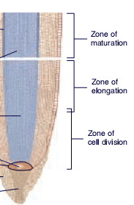
B. parenchyma
C. sclerenchyma
D. chlorenchyma
- In which zone of a root tip (figure at the right) the growth of root hairs start?
A. maturation
B. elongation
C. cell division
D. root cap
- Which of the following modified stems is for support and aid in climbing?
A. tendril
B. rhizome
C. tuber
D. stolon
- Which of the following is a response of a plant or plant part to contact with touch of an object?
A. phototropism
B. gravitropism
C. thigmotropism
D. thermotropism
- Which of the following is NOT a unique feature of meiosis?
A. homologous pairing through synapsis
B. homologous recombination through crossing-over
C. omitting chromosome duplication through reduction division
D. assembling of the microtubular apparatus that separate the sister chromatids

Numbers 164 -166 are about a bald woman that marries a non-bald man. Use the following key to answer the questions.
KEY: 1. X^{B}X^{B} 2. X^{B}X^{b} 3. X^{b} X^{b} 4. X^{B}Y^{B} 5. X^{B}Y^{b} 6. X^{b}Y^{b}
- What is the genotype of the man?
A. 3
B. 4
C. 5
D. 6
- If they have children, what will be the genotype of the son?
A. 3
B. 4
C. 5
D. 6
- What is the genotype of the woman?
A. 1
B. 2
C. 3
D. 4
- The human body is like the bustling factory that must have a transportation system to carry its various cargos back and forth. Instead of roads, railway trucks, and airways, the body’s delivery routes are its hollow blood vessels. Which of the following body systems is described as the transportation system of the human body?
A. lymphatic system
B. urinary system
C. cardiovascular system
D. respiratory system
- Estivation is a period of inactivity for animals experiencing conditions of extreme heat. Estivation serves the same function as which activity practiced by animals in cold environmental conditions?
A. camouflage
B. hibernation
C. migration
D. mimicry
- The fertilized eggs of most mammals follow a similar pattern of early development. Which sequence is the typical pattern, beginning with the earliest stage?
A. fetus ---- embryo ---- zygote
B. fetus ----zygote ---- embryo
C. zygote ---fetus --- embryo
D. zygote --- embryo --- fetus
- The structure of the digestive tube in the grasshopper and earthworm consists of many folds. The folds affect the efficiency of food absorption by which of the following functions?
A. increasing surface area
B. reducing transpiration
C. increasing hormone secretion
D. reducing storage of sugar
- Which relationship is most similar to the relationship below?
tRNA : ribosome
A. book : publisher
B. truck : factory
C. key : lock
D. baker : pie
- Which would most likely favor species survival in changing environmental conditions?
A. genetic recombination
B. energy involvement in gamete production
C. length of life cycle
D. number of offspring produced
- Which term BEST describes the type of cell division in which parent cells produce daughter cells with the same number of chromosomes as the parent cells?
A. mitosis
B. meiosis
C. spermatogenesis
D. oogenesis
- A karyotype of a human female shows that she has only one sex chromosome. Which genotype would represent her genetic condition?
A. XO
B. XXX
C. XY
D. XYY
- A paleontologist is comparing the fossilized remains of two primates. Both animals had a prehensile tail. What can be concluded from this evidence?
A. They were not related.
B. They lived on the ground.
C. They evolved from a common ancestor.
D. They had bipedal locomotion.
- Which could be considered biochemical evidence of an evolutionary relationship?
A. absence of vestigial structures
B. presence of embryonic gill slits
C. similar anatomical structures
D. presence of identical proteins
- Which is the BEST evidence of an evolutionary relationship between two organisms?
A. similarity in behavior
B. similarity in DNA
C. similarity in habitat
D. similarity in niche
- Which would most likely be caused by environmental conditions?
A. lung cancer
B. hemophilia
C. cystic fibrosis
D. sickle cell anemia
- Which situation would result in the greatest increase in the human population?
A. decreased birth rate and increased death rate
B. increased infant mortality and decreased death rate
C. decreased death rate and increased birth rate
D. increased birth rate and increased infant mortality

- A local scientist has studied the population distribution of a species of snail that lives on the sandy beaches of an island. The island experiences a volcanic eruption. The data from the scientist’s study of the snail population is summarized below.
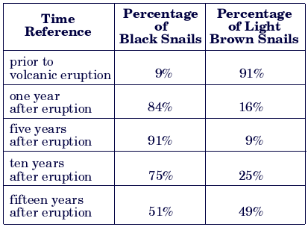
Prior to the volcanic eruption, which of the following could explain why the percentage of black snails was so much lower than the percentage of light brown snails?
A. The black color made them more likely to find food successfully.
B. The allele for black color is lethal in the homozygous condition.
C. The black snails were easier for predators to locate on the light-colored beach.
D. The light brown snails were better than the black snails at using all the available resources.
- In the carbon cycle, atmospheric carbon dioxide is converted into organic material by which process?
A. cellular respiration
B. decomposition
C. photosynthesis
D. transpiration
- If a cell that has 8 chromosomes goes through mitosis, how many chromosomes will each of the daughter cells have?
A. four
B. eight
C. sixteen
D. thirty two
- What is the role of restriction endonucleases in DNA technology?
A. cuts the DNA at specific recognition sites
B. reforms the double helix of DNA after denaturation
C. identifies and locates specific restriction sites on a given piece of DNA
D. makes copies of DNA in faster rate
- Merizza wants to know if the organism she is examining is an insect or an arachnid. If you were Merizza which structure you will examine?
A. feet
B. body segments
C. exoskeleton
D. abdomen
- Which of the following is a section of DNA within the chromosome that controls a specific trait?
A. nucleus
B. ribosome
C. gene
D. RNA

- Which parent’s sex chromosomes determine the sex of a child?
A. mother
B. father
C. grandmother
D. grandfather
- Which of the following is a nucleic acid that has the mold or template for each of the proteins responsible for the processes and features manifested by an individual?
A. mRNA
B. tRNA
C. DNA
D. allele
- Which of the following is the branch of biology that deals with heredity and variation?
A. embryology
B. evolution
C. genetics
D. biology
- Which of the following does NOT belong to the group of birds?
A. duck
B. ostrich
C. penguin
D. duck-billed platypus
- Which of the following is NOT present in a bacterium?
A. plasma membrane
B. true nucleus
C. cytoplasm
D. cell wall
- Which of the following refers to the passage of materials across the cell with the aid of protein carrier?
A. facilitated diffusion
B. passive transport
C. active transport
D. osmosis
- Which of the following glands controls the other endocrine glands?
A. pancreas
B. liver
C. pituitary
D. thyroid
- Why is placenta very important to a developing embryo? Because it __________.
A. is filled with fluid that protects the fetus
B. allows the mother’s blood to flow into the fetus
C. allows the mother’s life systems to support the fetus
D. prevents all drugs from reaching the fetus
- A couple wants to know the genetic condition of their baby before the mother give birth, what procedure can be used to diagnose and analyze the genes of the fetus?
A. amniocentesis
B. new-born screening
C. ultra sounding
D. DNA testing

- Why do ecosystems rarely contain more than a few trophic levels?
A. energy transfer efficiency is high
B. energy transfer efficiency is low
C. energy amounts remain constant
D. energy cannot flow through levels
- Silt and nutrients from eroding farmland flow into a lake. As a result, which will most likely increase first?
A. fish population
B. shore vegetation
C. algae growth
D. dissolved oxygen
- Ricky has trouble keeping his balance. What part of his nervous system might be functioning improperly?
A. cerebrum
B. medulla oblongata
C. cerebellum
D. spinal cord
- Which of the following is the function of the lymph nodes?
A. manage the exit of tissue fluid
B. allow the entry of the tissue fluid into the germinal centers
C. pick up the excess tissue fluid and return it to the bloodstream
D. help protect the body by removing foreign materials and produce lymphocytes
- What stage of menstrual cycle increases the level of progesterone to prepare the uterus for reception and implantation of the developing zygote?
A. follicular stage
B. menstrual stage
C. luteal stage
D. ovulation stage
- Which of the following refers to the animals that are active primarily at night?
A. diurnal
B. nocturnal
C. mimicry
D. molting

References:
- Raven and Johnson, 2002. Biology 6th Edition. Prentice Hall International.
- John Postlethwait and Janet Hopson, 2006. Modern Biology. Holt, Rinehart and Winston Press.
- Paul Agutter and Denys Wheatley 2007. Concepts in Modern Biology. Springer Publishing House.

KEY TO CORRECTION

- D
- B
- A
- B
- D
- A
- D
- D
- C
- C
- A
- D
- A
- D
- D
- C
- C
- D
- B
- C
- D
- D
- D
- A
- B
- B
- A
- B
- B
- A
- C
- C
- D
- B
- C
- D
- A
- D
- D
- D
- C
- D
- B
- A
- A
- B
- A
- D
- D
- C
- D
- D
- B
- D
- B
- C
- B
- C
- C
- D
- C
- D
- A
- B
- D
- A
- C
- A
- C
- C
- A
- A
- B
- B
- B
- B
- D
- B
- C
- A
- B
- D
- C
- B
- B
- A
- A
- B
- A
- D
- A
- C
- C
- B
- C
- A
- C
- D
- D
- B
- C
- D
- A
- C
- A
- A
- D
- C
- C
- C
- B
- B
- B
- D
- D
- B
- B
- B
- A
- B
- C
- B
- D
- D
- D
- A
- A
- B
- D
- C
- B
- A
- C
- C
- A
- C
- A
- B
- A
- C
- A
- D
- A
- A
- B
- C
- D
- A
- B
- C
- C
- C
- A
- B
- D
- B
- C
- A
- C
- A
- A
- C
- D
- D
- C
- A
- C
- B
- D
- A
- B
- A
- A
- A
- C
- D
- B
- A
- C
- C
- C
- B
- A
- A
- C
- B
- C
- C
- D
- B
- A
- C
- C
- A
- B
- C
- C
- D
- C
- B

