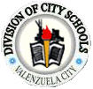
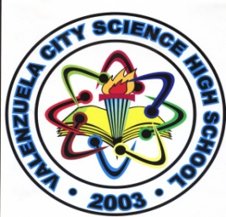

DepEd-National Capital Region
DIVISION OF CITY SCHOOLS – VALENZUELA
Valenzuela City

VALENZUELA CITY SCIENCE HIGH SCHOOL
A. Marcelo Street, Dalandanan Valenzuela City

RESEARCH II
Research/Success Calendar
Student Researchers:
1.) _____________________________ 4.) ___________________________
2.) _____________________________ 5.) ___________________________
3.) _____________________________
Field of Research: _______________ (Physical or Life Science) Category: _____________________
Research Topic/Title : ____________________________________________________________________
____________________________________________________________________________________________

Planned Date Date Completed Signature
1. Choosing a topic ____________ ______________ ____________

2. Collecting background information ____________ ______________ ____________

3. Problem and hypothesis ____________ ______________ ____________

4. Design for experiment ____________ ______________ ____________

5. Getting materials ready for ____________ ______________ ____________
experiment
6. Making the data table ____________ ______________ ____________

7. Recording in the data table ____________ ______________ ____________

8. Stating the results ____________ ______________ ____________

9. Drawing conclusions ____________ ______________ ____________

10. Compiling a bibliography ____________ ______________ ____________

11. Making the display ____________ ______________ ____________

