COLLEGE ADMISSION CHALLENGE REVIEW (COACH REVIEW)
IN BIOLOGY

Biology (from Greek βιολογία - βίος, bios, "life"; -λογία, -logia, study of) is the science that studies living organisms. Prior to the nineteenth century biology came under the general study of all natural objects called natural history. The term biology was first coined by the French naturalist Jean-Baptiste Lamarck. It is now a standard subject of instruction at schools and universities around the world, and over a million papers are published annually in a wide array of biology and medicine journals.
Biology examines the structure, function, growth, origin, evolution, distribution and classification of all living things. Five unifying principles form the foundation of modern biology: cell theory, evolution, gene theory, energy, and homeostasis.
Traditionally, the specialized disciplines of biology are grouped by the type of organism being studied: botany, the study of plants; zoology, the study of animals; and microbiology, the study of microorganisms. These fields are further divided based on the scale at which organisms are studied and the methods used to study them: biochemistry examines the fundamental chemistry of life, molecular biology studies the complex interactions of systems of biological molecules, cellular biology examines the basic building block of all life, the cell; physiology examines the physical and chemical functions of the tissues and organ systems of an organism; and ecology examines how various organisms interrelate with their environment.
CHEMISTRY OF LIFE (BIOCHEMISTRY)
Composition of Matter
Ø Everything in the universe is made of matter
Ø Matter takes up space & has mass
Ø Mass is a measure of the amount of matter in the substance
Ø Mass & weight are NOT the same
Ø Weight is a measure of the pull of gravity on an object
Question: Is the mass of an object the same on the moon as it is on the Earth? Is its weight the same? (Hint: Gravitational pull on the moon is 1/6 of that on the Earth.)
Ø Matter exists in 4 states – solid, liquid, gas, & plasma
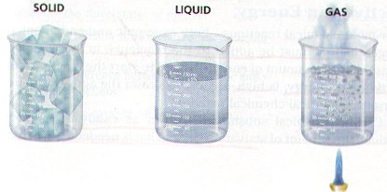
Ø Solids have both a definite volume & definite shape (rock)
Ø Liquids have a definite volume but no definite shape; they can be poured (water)
Ø Gases do not have a definite volume or definite shape, but they take the volume & shape of their container
Ø Plasmas have no definite volume, no definite shape, and only exist at extremely high temperatures such as the sun
Ø Chemical Changes in matter are essential to all life processes
Ø Biologists study chemistry because all living things are made of the same kinds of matter that make up nonliving things
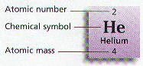
Elements
Ø Elements are pure substances which cannot be chemically broken down into simpler kinds of matter
Ø More than 100 elements have been identified, but only about 30 are important in living things
Ø All of the Elements are arranged on a chart known as the Periodic Table
Ø Periodic charts tell the atomic number, atomic mass, & chemical symbol for every element
Ø Four elements, Carbon – C, Hydrogen – H, Oxygen – O, and Nitrogen – N make up almost 90% of the mass of living things
Ø Every element has a different chemical symbol composed of one to two letters
Ø Chemical symbols usually come from the first letter or letters of an element like C for Carbon and Cl for Chlorine
Ø Some chemical symbols come form their Latin or Greek name such as Na for Sodium (natrium) or K for Potassium (Kalium)
Ø Elements in the same horizontal period on the periodic table have the same number of energy levels (e.g. H & He in period 1 have only a K energy level)
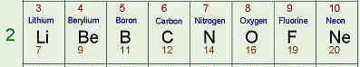
All Period 2 elements have 2 energy levels
(K & L)
Ø Elements in the same vertical Family on the periodic table have the same number of electrons in their outermost energy level & react similar (e.g. Family IV, the Carbon family all have 4 electrons in their outermost energy level)
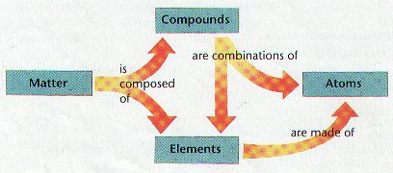
Atoms
Ø Atoms are the simplest part of an element that keeps all of the element’s properties
Ø Atoms are too small to be seen so scientists have developed models that show their structure & properties
Ø Atoms consist of 3 kinds of subatomic particles – protons & neutrons in the center or nucleus, and electrons spinning in energy levels around the center
Ø The nucleus is the center of an atom where most of the mass is concentrated
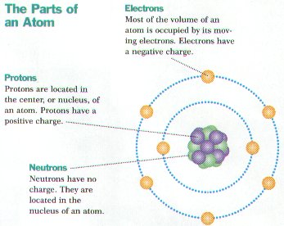
Ø Protons are positively charged ( p⁺ ), have a mass of 1 amu (atomic mass unit) , are found in the nucleus, and determine the atomic number of the element
Example: Carbon has 6 protons so its atomic number is 6
Ø Neutrons are neutral or have no electrical charge (n), have a mass of 1 amu, are found in the nucleus, and when added to the number of protons, determine the atomic mass of the element
Example: Sodium has 11 protons and 12 neutrons so its atomic mass is 11+12=23 amu
Ø Electrons (e⁻) are negatively charged, high energy particles with little mass that spin around the nucleus in energy levels
Ø Seven energy levels (K, L, M, N, O, P, & Q) exist around the nucleus and each holds a certain number of electrons
Ø The K energy level is closest to the nucleus & only holds 2 electrons, while the L – Q energy levels can hold 8 electrons
Ø Electrons in outer energy level are traveling faster & contain more energy than electrons in inner levels
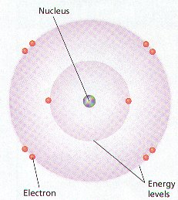
Ø The number of protons (positive charges) and electrons (negative charges in an atom are equal so the net electrical charge on a atom is zero making it electrically neutral
Ø Stable or non-reactive atoms have an outer energy level that is filled with electrons
Compounds
Ø Most elements do not exist by themselves; Most elements combine with other elements
Ø Compounds are made of atoms of two or more elements chemically combined
Ø Chemical Formulas represent a compound & show the kind & number of atoms of each element (e.g. H₂O has 2 hydrogen & 1 oxygen)
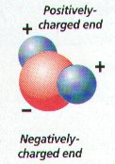
Ø Compounds have different physical & chemical properties than the atoms that compose them (e.g. hydrogen & oxygen are gases but H₂O is a liquid)
Ø The number & arrangement of electrons in an atom determines if it will combine to form compounds
Ø Chemical reactions occur whenever unstable atoms (outer energy level not filled) combine to form more stable compounds
Ø Chemical bonds form between atoms during chemical reactions
Types of Chemical Bonds
Ø Covalent bonds form between atoms whenever they share 1 or more pairs of electrons (e.g. H₂O)
Ø Molecules form from covalent bonding & are the simplest part of a compound (e.g. NaCl, H₂O, O₂)
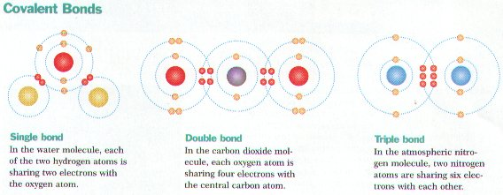
Ø Ionic bonding occurs between a positively & negatively charged atom or ion
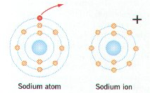
Ø Positively charged ions have more electrons (-) than protons (+); negatively charged ions have more protons than electrons
Ø Table salt (NaCl) forms when the 1 outer electron of Na is transferred to the outer energy level of chlorine that has 7 electrons (e⁻)
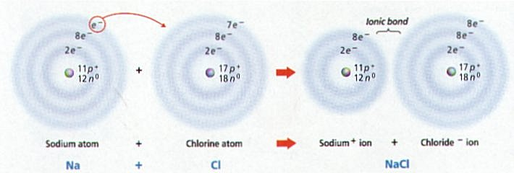
Ø Sodium (Na) with 1 less e⁻ becomes positively charged, while Chlorine (Cl) with 1 more e⁻ becomes negatively charged; the + and – charges attract & form the ionic bond holding NaCl together
Ø Other types of chemical bonding include hydrogen bonding
Energy
Ø Energy is the ability to do work
Ø Energy occurs in several forms & may be converted from one form to another
Ø Sunlight is the ultimate energy for all life on earth
Ø Forms of energy include chemical, electrical, mechanical, thermal, light, & sound
Ø Free energy is the energy available for work (e.g. cells have energy to carry out cell processes)
Ø Cells convert the chemical energy stored in food into other types of energy such as thermal & mechanical
Ø Energy is used to change matter form one state into another (e.g. liquid into a gas)
Chemical Reactions
Ø Living things undergo thousands of chemical reactions
Ø Chemical equations represent chemical reactions
Ø CO₂ + H₂0-----goes to-----H₂CO₃ (carbonic acid) is a sample Chemical Reaction in living things
Ø Reactants are on the left side of the equation, while products are on the right side
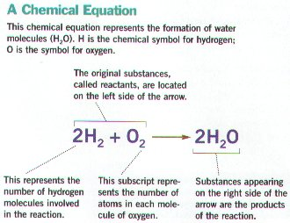
➢ Activation energy is required to start many reactions
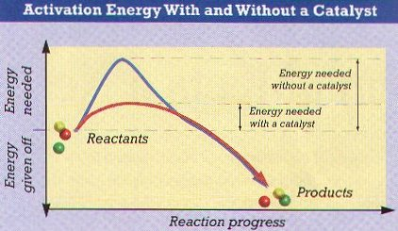
Ø Chemical bonds are broken, atoms rearranged, and new bonds form in chemical reaction
Ø Plants use sunlight to produce sugars such as C₆H₁₂O₆ glucose; the chemical energy from the sun is stored in the chemical bonds of glucose
Ø Organisms eat plants, break down the sugars, and release energy along with CO₂ & H₂O
Ø Exergonic reactions involve a net release of energy; while endergonic reactions involve a net absorption of energy
Ø Energy must be added to the reactants for most chemical reactions to occur; called activation energy
Ø Enzymes are chemical substances in living things that act as catalysts & reduce the amount of activation energy needed
Ø Organisms contain thousands of different enzymes
Ø Most enzymes end with –ase (e.g. lipase is the enzyme that acts on lipids)
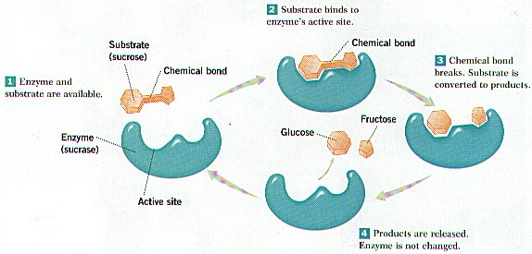
Reduction-Oxidation (Redox) reactions
Ø Reactions in which e- are transferred between atoms is a redox or reduction-oxidation reaction (e.g. formation of table salt NaCl)
Ø In oxidation reactions, a reactant loses 1 or more e- & becomes positively (+) charged (e.g. Sodium atom becomes a Na⁺ ion)
Ø In a reduction reaction, a reactant gains 1 or more e- and becomes negatively (-) charged (e.g. Chlorine atom becomes a Cl⁻ ion)
Ø REDOX reactions always occur together; the electron(s) from the oxidation reaction are then accepted by another substance in the reduction reaction
Solutions
Ø A large percentage of the mass of organisms is water & many of the chemical reactions of life occur in water
Ø A solution is a uniform mixture of one substance in anther
Ø Solutions may be mixtures of solids, liquids, or gases
Ø The solute is the substance uniformly dissolved in the solution & may be ions, molecules, or atoms
Ø The solvent is the substance in which the solute is dissolved
Ø Water is known as the universal solvent
Ø Dissolving one substance in another does not alter their chemical properties
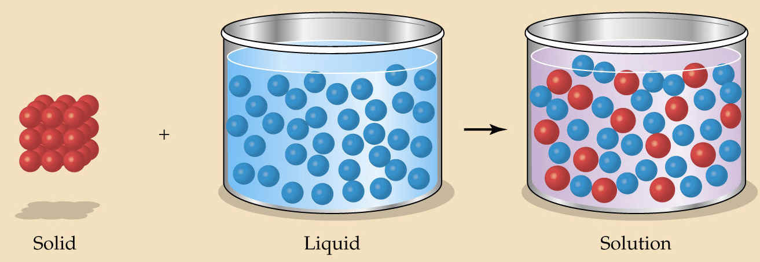
Ø The concentration of a solution is a measure of the amount of solute dissolved in a given volume of solvent
Ø Increasing the amount of solute increases the solution’s concentration
Ø Aqueous solutions are solutions in which water is the solvent; these are important in living things (e.g. blood, cytoplasm of cell...)
Acids and Bases
Ø The degree of acidity or alkalinity (basic) is important in organisms
Ø The force of attraction between molecules is so strong that the oxygen atom of one molecule can actually remove the hydrogen from other water molecules; called Dissociation
Ø H₂0-----GOES TO----- H⁺ + OH⁻
Ø OH⁻ called hydroxide ion; H⁺ called hydrogen ion
Ø Free H⁺ ion can react with another water molecule to form H₃O⁺ (hydronium ion)
Ø Acidity or alkalinity is a measure of the relative amount of H⁺ and OH⁻ ions dissolved in a solution
Ø Neutral solutions have an equal number of H⁺ and OH⁻ ions
Ø Acids have more H₃O⁺ ions than OH⁻ ions; taste sour; and can be corrosive
Ø Bases contain more OH⁻ ions than H₃O⁺ ions; taste bitter; & feel slippery
Examples of Common Acids  - citric acid (from certain fruits and veggies, notably citrus fruits)  - ascorbic acid (vitamin C, as from certain fruits)  - vinegar (5% acetic acid)  - carbonic acid (for carbonation of soft drinks)  - lactic acid (in buttermilk) | Examples of Common Bases  - detergents  - soap  - lye (NaOH)  - household ammonia
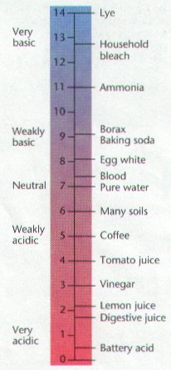
PH Scale
Ø Compares the relative concentration of H₃O⁺ ions and OH⁻ ions
Ø Scale ranges from 0 to 14; 0-3 is very acidic; 7 is neutral; 11-14 is very basic or alkaline
Ø Litmus paper, phenolphthalein, pH paper, & other indicators that change color can be used to measure pH
Buffers
Ø Control of pH is important to organisms
Ø Enzymes function only within a narrow pH range; usually neutral
Ø Buffers neutral acids or bases in organisms to help control pH
Physical Properties of Water
All of water’s unique physical properties are caused by water’s polarity.
- Cohesion: water molecules stick to each other. This is caused by hydrogen bonds that form between the slightly positive and negative ends of neighboring molecules. This is the reason why water is found in drops; perfect spheres. It’s hard to imagine water behaving any other way.
- Adhesion: water molecules stick to other surfaces. This causes water to move upward against gravity in plant stems and to be absorbed by paper towels. It also causes water to adhere to spider webs.
- Surface Tension: water has the ability to support small objects. The hydrogen bonds between neighboring molecules cause a “film” to develop at the surface. (Organisms like the water strider can be seen taking advantage of this property).
- Water has a high boiling point. Water is one of the few substances that remain a liquid at such a large range of temperatures (O-100 °C). A large amount of energy must be invested to overcome the hydrogen bonds in liquid water to change it to the gas phase.
- Capillary Action: water has the ability to “climb” structures. Think about what happens when you stick the tip of a straw in a glass of water.
- Ability to Dissolve: water is consider to be the universal solvent. More substances will dissolve in water than any other liquid. This includes other polar substances (such as sugar) and ionic compounds (such as salt).

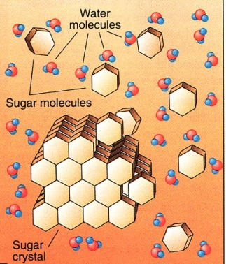
When a sugar crystal is placed in water, the slightly positive and negative ends of the water molecule attract the sugar molecules in the crystal (they are also polar) and pull them into solution.

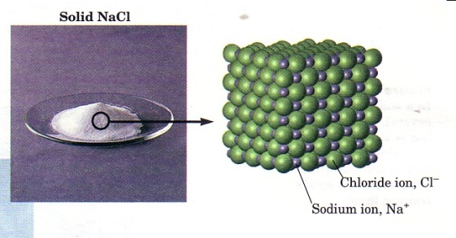
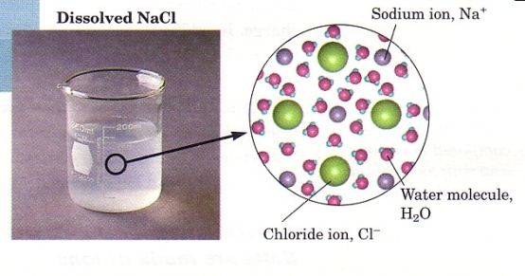
When salt crystals are placed in water, the slightly positive and negative ends of the water molecules attract the ions in the crystal. The ionic bonds holding the sodium and chlorine ions together are broken and the ions are pulled into solution.

- High Heat of Vaporization: Therefore, it absorbs much heat as it slowly rises, and gives off this heat as it slowly cools. It takes a large amount of heat to change water to steam. (Converting one gram of the hottest water to steam requires an input of 540 calories of heat energy.) Water has a high heat of vaporization because hydrogen bonds must be bro ken before boiling occurs and water molecules vaporize- that is, evaporate into the environment. This property of water helps keep body temperature within normal limits. Also, in a hot environment, we sweat; then the body cools as body heat is used to evaporate the sweat, which is mostly liquid water.
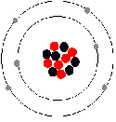
Organic Molecules
A. Most Common Elements
1. Most common elements in living things are carbon, hydrogen, nitrogen, and oxygen.
2. These four elements constitute about 95% of your body weight.
3. Chemistry of carbon allows the formation of an enormous variety of organic molecules.
4. Organic molecules have carbon and hydrogen; determine structure and function of living things.
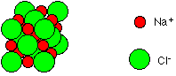
5. Inorganic molecules do not contain carbon and hydrogen together; inorganic molecules (e.g., NaCl) can play important roles in living things.
B. Small Molecules Have Functional Groups
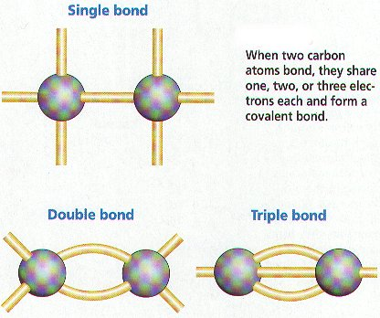
1. Carbon has four electrons in outer shell; bonds with up to four other atoms (usually H, O, N, or another C).
2. Ability of carbon to bond to itself makes possible carbon chains and rings; these structures serve as the backbones of organic molecules.
3. Functional groups are clusters of atoms with characteristic structure and functions.
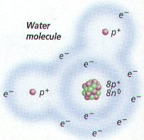
a. Polar molecules (with +/- charges) are attracted to water molecules and are hydrophilic.

b. Nonpolar molecules are repelled by water and do not dissolve in water; are hydrophobic.

c. Hydrocarbon is hydrophobic except when it has an attached ionized functional group such as carboxyl (acid) (COOH); then molecule is hydrophilic.
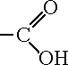
d. Cells are 70-90% water; degree organic molecules interact with water affects their function.
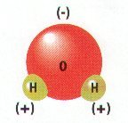
4. Isomers are molecules with identical molecular formulas but differ in arrangement of their atoms
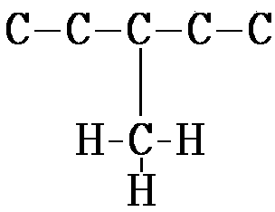 | 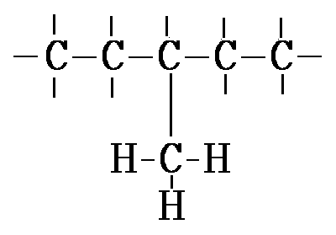
C. Large Organic Molecules Have Monomers
1. Each small organic molecule can be a unit of a large organic molecule called a macromolecule.
2. Small organic molecules (e.g., monosaccharides, glycerol and fatty acid, amino acids, and nucleotides) that can serve as monomers, the subunits of polymers.
3. Polymers are the large macromolecules composed of three to millions of monomer subunits.
4. Four classes of macromolecules (polysaccharides or carbohydrates, triglycerides or lipids, polypeptides or proteins, & nucleic acids such as DNA & RNA) provide great diversity.
D. Condensation Is the Reverse of Hydration
1. Macromolecules build by different bonding of different monomers; mechanism of joining and breaking these bonds is condensation and hydrolysis.
2. Cellular enzymes carry out condensation and hydrolysis of polymers.
3. Condensation involves a dehydration synthesis because a water is removed (dehydration) and a bond is made (synthesis).
a. When two monomers join, a hydroxyl ( OH) group is removed from one monomer and a hydrogen is removed from the other.
b. This produces the water given off during a condensation reaction.
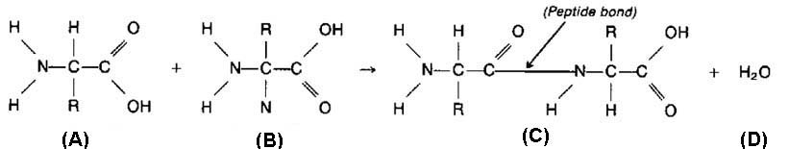
4. Hydrolysis (hydration) reactions break down polymers in reverse of condensation; a hydroxyl
( OH) group from water attaches to one monomer and hydrogen ( H) attaches to the other.
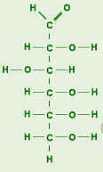
Carbohydrates
A. Monosaccharides, Disaccharides, and Polysaccharides
1. Monosaccharides are simple sugars with a carbon backbone of three to seven carbon atoms.
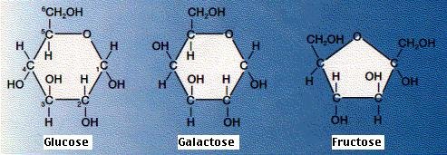
a. Best known sugars have six carbons (hexoses).
Sugar | Sweetness
fructose | 173%
sucrose | 100%
glucose | 74%
maltose | 33%
galactose | 33%
lactose | 16%

1) Glucose and fructose isomers have same formula (C₆H₁₂O₆) but differ in structure.
2) Glucose is commonly found in blood of animals; is immediate energy source to cells.
3) Fructose is commonly found in fruit.
4) Shape of molecules is very important in determining how they interact with one another.
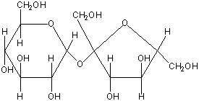
2. Ribose and deoxyribose are five-carbon sugars (pentoses); contribute to the backbones of RNA and DNA, respectively.
3. Disaccharides contain two monosaccharides joined by condensation.
a. Sucrose is composed of glucose and fructose and is transported within plants.
b. Lactose is composed of galactose and glucose and is found in milk.
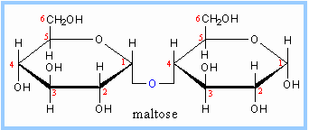
c. Maltose is two glucose molecules; forms in digestive tract of humans during starch digestion.

B. Polysaccharides Are Varied in Structure and Function
1. Polysaccharides are chains of glucose molecules or modified glucose molecules
a. Starch is straight chain of glucose molecules with few side branches.
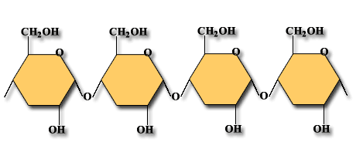
b. Glycogen is highly branched polymer of glucose with many side branches; called "animal starch," it is storage carbohydrate in the liver of animals.
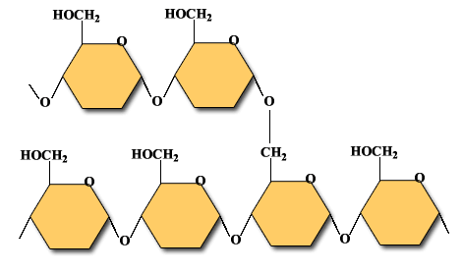
c. Cellulose is glucose bonded to form microfibrils; primary constituent of plant cell walls.
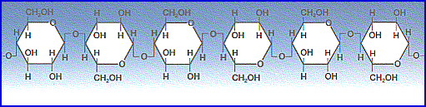
d. Chitin is polymer of glucose with amino acid attached to each; it is primary constituent of crabs and related animals like lobsters and insects.
Lipids
A. Lipids
1. Lipids are varied in structure.
2. Many are insoluble in water because they lack polar groups.
B. Fats and Oils Are Similar
1. Each fatty acid is a long hydrocarbon chain with a carboxyl (acid) group at one end.
a. Because the carboxyl group is a polar group, fatty acids are soluble in water.
b. Most fatty acids in cells contain 16 to 18 carbon atoms per molecule.
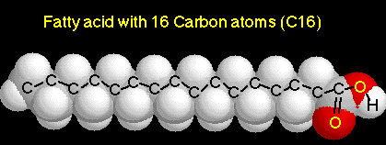
c. Saturated fatty acids have no double bonds between their carbon atoms. (C-C-C-)
d. Unsaturated fatty acids have double bonds in the carbon chain.(C-C-C-C=C-C-)
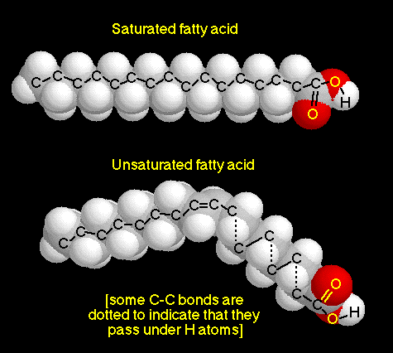
e. Saturated animal fats are associated with circulatory disorders; plant oils can be substituted for animal fats in the diet.
2. Glycerol is a water-soluble compound with three hydroxyl groups.

3. Triglycerides are glycerol joined to three fatty acids by condensation
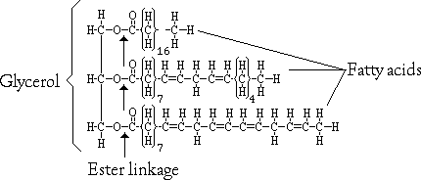
4. Fats are triglycerides containing saturated fatty acids (e.g., butter is solid at room temperature).
5. Oils are triglycerides with unsaturated fatty acids (e.g., corn oil is liquid at room temperature).
6. Fats function in long-term energy storage in organisms; store six times the energy as glycogen.
C. Waxes Are Nonpolar Also
1. Waxes are a long-chain fatty acid bonded to a long-chain alcohol.
a. Solid at room temperature; have a high melting point; are waterproof and resist degradation.
b. Form protective covering that retards water loss in plants; maintain animal skin and fur.
D. Phospholipids Have a Polar Group
1. Phospholipids are like neutral fats except one fatty acid is replaced by phosphate group or a group with both phosphate and nitrogen
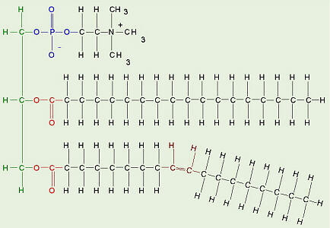
2.Phosphate group is the polar head: hydrocarbon chain becomes nonpolar tails
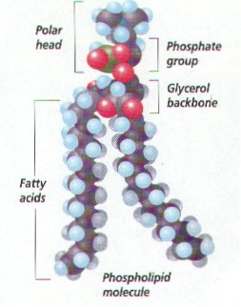
3. Phospholipids arrange themselves in a double layer in water, so the polar heads face outward toward water molecules and nonpolar tails face toward each other away from water molecules.
4. This property enables them to form an interface or separation between two solutions (e.g., the interior and exterior of a cell); the plasma membrane is a phospholipid bilayer.
E. Steroids Have Carbon Rings
1. Steroids differ from neutral fats; steroids have a backbone of four fused carbon rings; vary according to attached functional groups.
2. Cholesterol is a precursor of other steroids, including aldosterone and sex hormones.
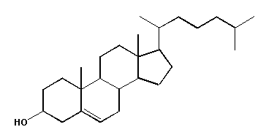

3. Testosterone is the male sex hormone.
4. Functions vary due primarily to different attached functional groups.
Proteins
A. Amino Acids
1. Amino acids are the monomers that condense to form proteins, which are very large molecules with structural and metabolic functions.
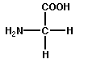
2. Structural proteins include keratin, which makes up hair and nails, and collagen fibers, which support many organs.
3. Myosin and actin proteins make up the bulk of muscle.
4. Enzymes are proteins that act as organic catalysts to speed chemical reactions within cells.
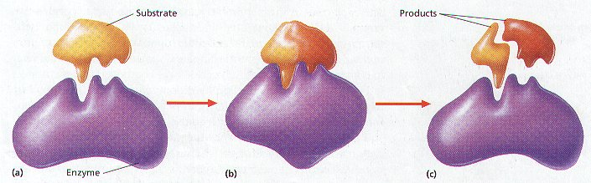
5. Insulin protein is a hormone that regulates glucose content of blood.
6. Hemoglobin transports oxygen in blood.
7. Proteins embedded in the plasma membrane have varied enzymatic and transport functions.
B. Peptide Bonds Join Amino Acids
1. All amino acids contain a carboxyl (acid) group ( COOH) and an amino group ( NH₂).
2. Both ionize at normal body pH to produce COO⁻ and NH+; thus, amino acids are hydrophilic.
3. Peptide bond is a covalent bond between amino acids in a peptide; results from condensation reaction.
a. Atoms of a peptide bond share electrons unevenly (oxygen is more electronegative than nitrogen).
b. Polarity of the peptide bond permits hydrogen bonding between parts of a polypeptide.
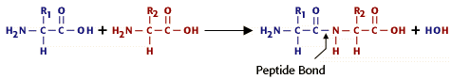

4. Amino acids differ in nature of R group, ranging from single hydrogen to complicated ring compounds.
a. R group of amino acid cysteine ends with a sulfhydryl ( SH) that serves to connect one chain of amino acids to another by a disulfide bond ( S S).
b. There are 20 different amino acids commonly found in cells.
5. A peptide is two or more amino acids joined together.
a. Polypeptides are chains of many amino acids joined by peptide bonds.
b. Protein may contain more than one polypeptide chain; it can have large numbers of amino acids.
C. Proteins Can Be Denatured
1. Both temperature and pH can change polypeptide shape.
a. Examples: heating egg white causes albumin to congeal; adding acid to milk causes curdling. When such proteins lose their normal configuration, the protein is denatured.
b. Once a protein loses its normal shape, it cannot perform its usual function.
2. The sequence of amino acids, therefore, forecasts the protein's final shape.

D. Proteins Have Levels of Structure
1. Final 3-D shape of a protein determines function of the protein in the organism.
a. Primary structure is sequence of amino acids joined by peptide bonds.
1) Frederick Sanger determined first protein sequence, with hormone insulin, in 1953.
a) First broke insulin into fragments and determined amino acid sequence of fragments.
b) Then determined sequence of the fragments themselves.
c) Required ten years research; modern automated sequencers analyze sequences in hours.
2) Since amino acids differ by R group, proteins differ by a particular sequence of the R groups.
b. Secondary structure results when a polypeptide takes a particular shape.
1) The (alpha) helix was the first pattern discovered by Linus Pauling and Robert Corey.
a) In peptide bonds, oxygen is partially negative, hydrogen is partially positive.
b) Allows hydrogen bonding between the C O of one amino acid and the N H of another.
c) Hydrogen bonding between every fourth amino acid holds spiral shape of a helix.
d) helices covalently bonded by disulfide (S S) linkages between two cysteine amino acids.
2) The sheet was the second pattern discovered.
a) Pleated sheet polypeptides turn back upon themselves; hydrogen bonding occurs between extended lengths.
b) keratin includes keratin of feathers, hooves, claws, beaks, scales, and horns; silk also is protein with sheet secondary structure.
3. Tertiary structure results when proteins of secondary structure are folded, due to various interactions between the R groups of their constituent amino acids
4. Quaternary structure results when two or more polypeptides combine.
1) Hemoglobin is globular protein with a quaternary structure of four polypeptides.
2) Most enzymes have a quaternary structure.

Nucleic Acids
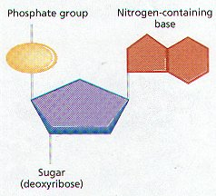
A. Nucleotides
1. Nucleotides are a molecular complex of three types of molecules: a phosphate (phosphoric acid), a pentose sugar, and a nitrogen-containing base.
2. Nucleotides have metabolic functions in cells.
a. Coenzymes are molecules, which facilitate enzymatic reactions.
b. ATP (adenosine triphosphate) is a nucleotide used to supply energy.
c. Nucleotides also serve as nucleic acid monomers.
B. Nucleic Acids
1. Nucleic acids are huge polymers of nucleotides with very specific functions in cells.
2. DNA (deoxyribonucleic acid) is the nucleic acid whose nucleotide sequence stores the genetic code for its own replication and for the sequence of amino acids in proteins.
3. RNA (ribonucleic acid) is a single-stranded nucleic acid that translates the genetic code of DNA into the amino acid sequence of proteins.
4. DNA and RNA differ in the following ways:
a. Nucleotides of DNA contain deoxyribose sugar; nucleotides of RNA contain ribose.
b. In RNA, the base uracil occurs instead of the base thymine, as in DNA.
c. DNA is double-stranded with complementary base pairing; RNA is single-stranded.
1) Complementary base pairing occurs where two strands of DNA are held together by hydrogen bonds between purine and pyrimidine bases
2) The number of purine bases always equals the number of pyrimidine bases; called Chargaff's rule
3) Adenine pairs with Thymine & guanine pairs with cytoseine on DNA
4) Guanine & adenine are purines; Cytosine & thymine are pyrimidines
d. Two strands of DNA twist to form a double; RNA generally does not form helices.
C. ATP (Adenosine Triphosphate)
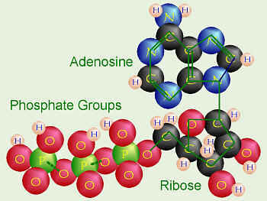
1. ATP (adenosine triphosphate) is a nucleotide of adenosine composed of ribose and adenine.
2. Derives its name from three phosphates attached to the five-carbon portion of the molecule.
3. ATP is a high-energy molecule because the last two unstable phosphate bonds are easily broken.
4. Usually in cells, a terminal phosphate bond is hydrolyzed, leaving ADP (adenosine diphosphate).
5. ATP is used in cells to supply energy for energy-requiring processes (e.g., synthetic reactions); whenever a cell carries out an activity or builds molecules, it "spends" ATP.

Summary of Biological Macromolecules:
Macromolecule | Building Blocks | Functions
Polysaccharides | Sugars (monosaccharides) | - Energy storage (4 Cal/gm)  - Structure (cell walls, exoskeletons)
Lipids (Triglycerides) | Fatty acids, glycerol | - Energy storage (9 Cal/gm)
Lipids (Phospholipids) | Fatty acids, glycerol, phosphate group | - Cell membranes
Proteins | Amino acids (20 types) | - Cell structure  - Enzymes  - Molecular motors (muscle, etc)  - Membrane pumps & channels  - Hormones & receptors  - Immune system: antibodies
Nucleic Acids: DNA  (forms a double helix) | - 4 Bases: A, C, G, T  - Deoxyribose sugar  - Phosphate  - Subunits called nucleotides | - Storage of hereditary information (genetic code)
Nucleic Acids (RNA)  3 types:  - m-RNA  - t-RNA  - r-RNA  (usually a single strand) | - 4 Bases: A, C, G, U  - Ribose sugar  - Phosphate  - Subunits called nucleotides | Protein synthesis:  - m-RNA: working copy of genetic code for a gene (transcription)  - t-RNA & r-RNA: translation of the code

CELL BIOLOGY

All Organisms are Made of Cells
- The cell is the basic unit of structure & function
- The cell is the smallest unit that can still carry on all life processes
- Both unicellular (one celled) and multicellular (many celled) organisms are composed of
cells
- Before the 17th century, no one knew cells existed
- Most cells are too small to be seen with the unaided eye
- In the early 17th century microscopes were invented & cells were seen for the 1st time
- Anton Von Leeuwenhoek, a Dutchman, made the 1st hand-held microscope & viewed microscopic organisms in water & bacteria from his teeth

- Leeuwenhoek's microscope consisted simply of:
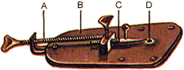
- A) a screw for adjusting the height of the object being examined
- B) a metal plate serving as the body
- C) a skewer to impale the object and rotate it
- D) the lens itself, which was spherical

- In 1665, an English scientist named Robert Hooke made an improved microscope and viewed thin slices of cork viewing plant cell walls
- Hooke named what he saw "cells"
- In the 1830’s, Matthias Schleiden (botanist studying plants) & Theodore Schwann (zoologist studying animals) stated that all living things were made of cells
- In 1855, Rudolf Virchow stated that cells only arise from pre-existing cells
- Virchow’s idea contradicted the idea of spontaneous generation (idea that nonliving things could give rise to organisms)
- The combined work of Schleiden, Schwann, & Virchow is known as the Cell Theory
Cell Theory
- All living things are made up of cells.
- The cell is the basic structural and functional unit of life.
- All cells come from pre-existing cells.

Animal Cell Structure
Cells have many organelles that perform various functions important to the cell's survival.
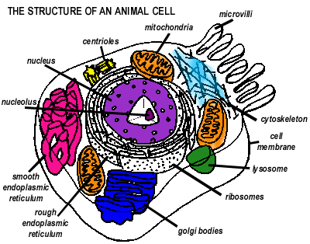
The cell membrane is located around the outside of the cell. It is a protein lipid bilayer. The hydrophilic heads of the lipids point outwards while the hydrophobic tails occupy the space between the two lipid layers. Several types of proteins are imbedded in the membrane: channel, transport, recognition, receptor, and electron transfer. Channel proteins provide passageways through the membrane for small substances to diffuse through. Transport proteins are involved in the active transport of substances across the membrane. Recognition proteins recognize other cells. Receptor proteins are receptor sites for hormones and other chemicals. Electron transfer proteins are involved in the transfer of electrons in processes like photosynthesis and cellular respiration. Because the proteins constantly shift throughout the cell membrane, it is referred to as a fluid mosaic model. The functions of the cell membrane include: holding cellular material, regulating the movement of materials across the membrane, providing a surface for many chemical reactions, and identifying the cell to the body's immune system.

- Cell junctions connect one cell to another. Gap junctions are found in animals and are very, very small channels that allow various ions and other small substances to pass from one cell to another. Tight junctions are seals around cells to prevent leakage. They are important for containing liquids like stomach acids. Desmosomes are spot welds that hold cells together.
- The nucleus controls the cell's activities and contains all the genetic material (46 chromosomes in humans).
- The nucleolus is involved in the synthesis of ribosomal RNA. It is a dark body inside the nucleus.
- The nuclear membrane keeps DNA inside the nucleus but allows mRNA and proteins through. It is a double membrane with large pores.
- Ribosomes assemble proteins from RNA codes. They are found free-floating in the cytoplasm throughout the cell or attached to the endoplasmic reticulum.
- The smooth endoplasmic reticulum is a series of long canals running throughout the cell. It detoxifies the cell and converts foodstuffs.
- The rough endoplasmic reticulum is a series of long canals running throughout the cell with ribosomes attached. It transports proteins to the golgi bodies for packaging.
- Golgi bodies (also apparatus or complex) store and package cellular secretions for export out of the cell (usually through the use of vacuoles). Salivary, oil, and digestive glands have very active golgi bodies.
- Lysosomes digest and remove worn out cell organelles. In essence, they are vacuoles filled with digestive enzymes.
- Mitochondria produce most of the cell's energy. They are composed of two membranes (an outer and a folded inner membrane) and are common in muscle cells.
- Centrioles anchor spindle fibers during cell division. They are composed of microtubules and are only found in animal cells.
- The cell's cytoskeleton provides the cell with shape and support. It is involved in cell movement (cytoplasmic streaming, muscle contraction, ameboid movement, and cell division). The cytoskeleton is composed of actin filaments, intermediate filaments, and microtubules.
- Vacuoles are "bubbles" of material in the cell. Usually vacuoles hold water. They can, however, hold solutions and solid material as well.
- Some cells have microvilli to aid in movement or absorption.

Plant Cell Structure
Plant cells have all of the same organelles as animal cells except:
- Plant cells don't have centrioles.
- Plant cells have another kind of cell junction called plasmodesmata.
- Plants have leucoplasts that store starch, oil, or protein.
- Plants have chloroplasts that are active in photosynthesis. Chloroplasts have a double membrane and contain chlorophyll.
- Plants have cell walls made of cellulose in addition to cell membranes. (Note: bacteria have cell walls made of peptidoglycan and fungi have cell walls made of chitin)
- Water vacuoles in plants are much larger and support much of the cell.
Prokaryotes vs. Eukaryotes
- Prokaryotes are the earliest and simplest cells on Earth. Eukaryotes are more modern cells. All the cells described so far are eukaryotic.
- In prokaryotes, there is no nucleus and genetic material floats freely in the cytoplasm. Prokaryotes also lack all the other organelles except for cell walls and ribosomes. Additionally, the cell walls in prokaryotic organisms are made of peptidoglycan instead of cellulose and the ribosomes are smaller.
Cell Transport
- The purpose of cell transport is to maintain homeostasis. The different kinds of cell transport are divided into two categories: those that require energy and those that do not.
- Passive transport does not require energy. There are three kinds of passive transport. In diffusion substances move from high concentrations to low concentrations. In facilitated diffusion substances move from high concentrations to low concentrations via carrier proteins. Finally, in osmosis water moves from high concentrations (of water) to low concentrations.
- Active transport requires energy and usually moves substances from low concentrations to high concentrations against the concentration gradient. In endocytosis, a form of active transport, the cell engulfs material. In exocytosis, the cell expells material.

BIOENERGETICS
CELLULAR RESPIRATION
General Equation
After the three steps in cellular respiration glucose and oxygen are turned into carbon dioxide, water, and energy in the following equation:
C₆H₁₂O₆ + 6O₂ --> 6CO₂ + 6H₂O + energy
Structure of Mitochondria

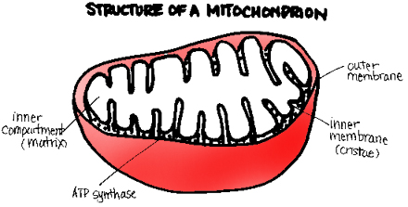
Image by Chernobyl Frog Dissections
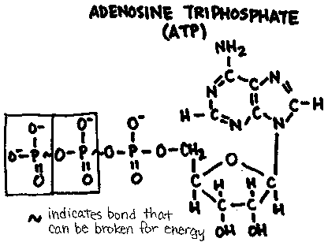
Most of cellular respiration takes place in the mitochondria. The mitochondria is a double membrane bound organelle. The outer membrane encloses an inner membrane called the cristae. The area inside the cristae is called the matrix. The Krebs Cycle occurs in the matrix while electron transport takes place on the cristae.
Glycolysis
Unlike the other steps in cellular respiration, glycolysis occurs in the cytoplasm. In glycolysis, a molecule of glucose is converted into two pyruvates and two NADH are produced. Two ATP, the body's source of energy, are used and four ATP are produced -- a net gain of two ATP.
The Krebs Cycle
Before the pyruvates formed in glycolysis enter the Krebs Cycle, the body must have enough oxygen. If no oxygen is present, then fermentation occurs. Otherwise, the pyruvates undergo an intermediate step and enter the Krebs Cycle.
In the intermediate step, each pyruvate is attached to acetyl-CoA. Two NADH (one for each pyruvate) and a two molecules of carbon dioxide is formed.
Each pyruvate must pass through the Krebs Cycle. Through a series of reactions, 3 NADH and 2 FADH₂ are formed. Multiplied by two for the two pyruvates, a total of 6 NADH and 4 FADH₂ are formed. These products along with the 2 NADH formed in glycolysis enter the electron transport system.

The Electron Transport System (ETC)
The electron transport system is a series of proteins imbedded on the cristae of mitochondria. The NADH and FADH₂ produced in glycolysis and the Krebs Cycle enter the electron transport system. There, the electrons from NADH pass through three proteins and pump a total of 6 protons across the cristae. The electrons from FADH₂ pass through two proteins and pump a total of 4 protons across the membrane. Then, every two protons diffuse back through an ATP-synthase and produce one ATP. A total of 34 ATP are produced this way.
Anaerobic Respiration
Anaerobic respiration occurs in the cytoplasm when no oxygen is present for the cell to continue respiration after glycolysis. There are two common forms of anaerobic respiration:
- Alcoholic fermentation occurs in plants, fungi, and bacteria. Each pyruvate is converted to a molecule of ethanol and one NADH is used in the reaction.
- Lactate fermentation occurs in animals. Each pyruvate is converted to lactate and one NADH is used.
The purpose of both fermentation processes is to free NADH for use in glycolysis.

PHOTOSYNTHESIS

General Equation
In photosynthesis, carbon dioxide and water are converted into glucose and oxygen. The general equation is
light + 6CO₂ + 12H₂0 --> C₆H₁₂O₆ + 6O₂ + 6H₂0
Structure of a Chloroplast
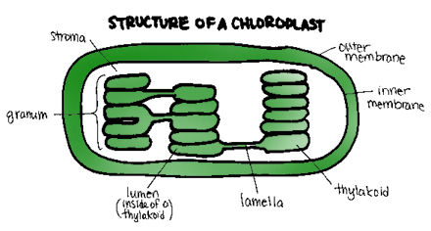
Chloroplasts are double membrane bound organelles crucial in photosynthesis. The area between the outer membrane and the inner membrane (thylakoid) is called the stroma. Stacks of thylakoids are called granum. Both the light and light-independent (dark) reactions of photosynthesis occur here.

Light Reactions
There are two pathways involved in the light reaction.
In noncyclic photophosphorylation, a photon of light excites P680 which ejects two electrons. These electrons are picked up and passed through various proteins, eventually pumping two hydrogen ions across the thylakoid membrane, phosphorylating one ATP, and entering P700. A photon of light hitting P700 also causes it to eject two electrons. These, too, are passed through a protein chain, pumping through two hydrogen ions and forming one NADPH. These products then enter the dark, or light-independent, reaction.
In cyclic photophosphorylation, a photon of light excites P700 which ejects two electrons. These electrons are passed through a chain of proteins and two hydrogen are pumped through the thylakoid membrane. No ATP or NADPH is produced, however. The electrons then return to P700 (by the way of plastocyanin) and the cycle begins anew.
Dark Reactions
The dark (Calvin-Bensen) reaction is also referred to as the light-independent reaction since it occurs with or without the presence of light. In the Calvin-Bensen Cycle, carbon dioxide, NADPH, hyrdogen ions, and ATP are converted into glucose, water, NADPH⁺, ADP, and phosphate.
Photorespiration
Rubisco (Ribulose Biphosphate Carboxylase) is an allosteric enzyme involved in photosynthesis in which oxygen and carbon dioxide compete for the same binding site. If carbon dioxide levels are high, more carbon dioxide binds to rubisco and photosynthesis continues. If oxygen levels are high, however, then oxygen binds to rubisco and produces carbon dioxide and ammonia. This is wasteful since no ATP or NADPH is formed.
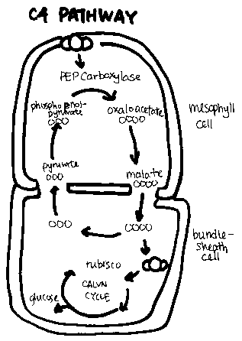
C4 Carbon Fixation
C₄ Carbon Fixation is a method some plants use to avoid the problems associated with rubisco and photorespiration. C₄ plants carry out the light reactions of photosynthesis in the mesophyll like other plants, but they carry out the light-independent reactions in the bundle sheath cells. The enzyme in the bundle sheath cells, PEP carboxylase, has a higher affinity for grabbing carbon dioxide than rubisco. This gives C₄ plants a better chance of survival in tightly packed areas where carbon dioxide may be limited.
CAM Pathway
The CAM pathway (Crassulacean Acid Metabolism) is utilized by cacti, other succulents, and members of the crassulaceae. The CAM pathway uses up more energy, resulting in stunted growth, but it vital in environments where water loss is the difference between life and death. CAM plants open their stomates at night to take in carbon dioxide and close them (reducing water loss) in the day.

CELL DIVISION

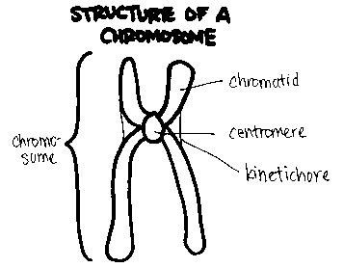
Structure of a Chromosome
A chromosome is composed of two identical chromatids attached by a centromere. Each chromatid is made up of tightly wound DNA wrapped around histones. During cell division, spindle fibers attach to the kinetochore.
The Cell Cycle
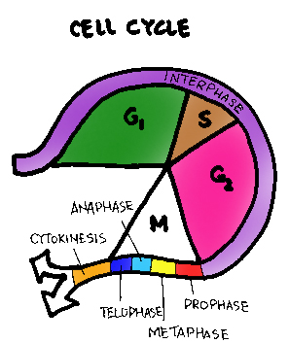
The cell cycle is divided into six phases. The first phase is interphase. In interphase, the cell is not actively dividing. Instead, it is carrying out everyday activities. There are three stages in interphase:
- In the G₁ stage of interphase, there is a high rate of replication of organelles and protein synthesis.
- In the S stage of interphase, DNA is replicated.
- In the G₂ stage of interphase, the mitotic apparatus are produced.
The next four phases are in mitosis.
The last phase is cytokinesis. In cytokinesis, cellular organelles and the cytoplasm are divided between the two new cells.

Mitosis
There are four stages in mitosis.
- In prophase the nucleus, the nuclear membrane, and the nucleolus start to disappear. The spindle fibers and centrioles (remember: there are no centrioles in plant cells) become visible and the chromosomes condense.
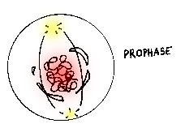
Image by Chernobyl Frog Dissections
- In metaphase the chromosomes line up along the center of the cell and kinetichore proteins attach to the spindle fibers.
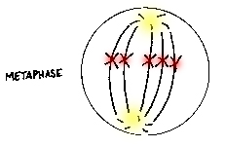
Image by Chernobyl Frog Dissections

- In anaphase the chromosomes are pulled apart at the centromere towards opposite poles.
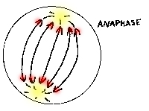
Image by Chernobyl Frog Dissections
- In telophase the nuclear membrane, nucleus, and nucleolus reappear. The chromosomes and spindle fibers disperse.
After mitosis, cytokinesis occurs. In plant cells, the golgi complex forms the middle lamella (cell plate). In animal cells, the cell membrane pinches in until two new cells are formed.

Meiosis

Meiosis has eight stages and results in the formation of gametes (sex cells with half the number of chromosomes of a normal cell).
- Prophase I of meiosis is similar to prophase of mitosis. The difference is that homologous chromosomes (each homologue is from a different parent) attach to form tetrads. The exchange of genetic material between homologous chromosomes, or crossing-over, occurs.
- In metaphase I tetrads line up in the middle of the cell and spindle fibers attach to each centromere.
- In anaphase I one homologue is pulled to each pole.
- In telophase I the nuclei are reorganized and the chromosomes are decondensed. This phase is followed by a special meiotic interphase where no DNA replication occurs.
- In prophase II the nucleus disappears and the chromosomes condense.
- In metaphase II the chromosomes line up in the middle of the cell and the spindle fibers attach to kinetichore proteins.
- In anaphase II the chromosomes separate and the chromatids are pulled to the poles. Each cell now has half as many chromosomes as it used to.
- In telophase II the nucleus is reorganized, the chromosomes are decondensed, the centrioles do not replicate, and the cell remains in the G₁ phase.

Mitosis vs. Meiosis
There are several important differences between mitosis and meiosis.
First, mitosis results in the formation of two daughter cells identical to the original cell. Meiosis forms four gametes: cells with half the chromosomes of the original cell.
Second, mitosis is a single cell division. Meiosis is a replication followed by a reduction.
Third, mitosis has four stages. Meiosis has eight stages.
Fourth, in prophase of mitosis, the individual chromosomes line up in the middle of the cell and the chromatids are pulled to the poles. In prophase I of meiosis, the tetrads line up in the middle of the cell and the chromosomes are pulled to the poles.
Fifth, there is no crossing-over occuring in mitosis. In meiosis, crossing-over occurs in prophase I.

GENETICS

Mendel's Principles

Gregor Mendel, a monk, formulated the following principles from observations he made during the cross-breeding of pea plants.
- The Principle of Unit Characters states that individuals pass information on as individual traits.
- The Principle of Dominance states that some unit characters can mask the expression of others.
- The Principle of Segregation states that each unit character separates into a different sex cell.
- The Principle of Independent Assortment states that genes segregate according to chance.
Genes and Alleles
There are several terms to be familiar with before continuing.
- Genes are genetic material on a chromosome that code for a trait. For example, you have a gene for eye color.
- Alleles are variations of genes. For example, you have the allele for brown eye color. Note that some alleles are dominant over others. That is, if a person inherits both the dominant and the recessive alleles, the dominant allele will be the one expressed.
- A genotype is the actual set of alleles an organims carries. For example, you have the genotype Bb since you have the allele for brown eye color (B) and the allele for blue eye color (b). An organism is said to be homozygous for a certain trait if both it carries two of the same alleles. It is homozygous dominant if it carries two dominant alleles and homozygous recessive if it carries two recessive alleles. The organism in our example is heterozygous -- it carries two different alleles.
- A phenotype is the expression of a gene. For example, since you have the genotype Bb with one dominant and one recessive allele, the dominant allele (B) will mask the recessive allele (b) and you will have the phenotype for brown eyes.
Monohybrid Crosses
- Monohybrid crosses deal with a single trait. When studying monohybrid crosses it is useful to make a Punnett square. In a Punnett square, the genotype of one parent is written across the top while the genotype of the other parent is written vertically to the left. The cross is made and the possible genotypes of the offspring show up in the four boxes below.
- Example:
In humans, Widow’s peak (W) is dominant over non-widow’s peak (w). A man who is heterozygous for widow’s peak marries a woman who is heterozygous for widow’s peak. What are the possible genotypes of their offspring?
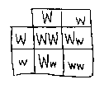
Image by Chernobyl Frog Dissections

Sometimes you are information about the offspring and are asked to obtain information about the parents.
- Example:
In pea plants, yellow seeds (Y) are dominant and green seeds (y) are recessive. A pea plant with yellow seeds is crossed with a pea plant with green seeds. The resulting offspring have about equal numbers of yellow and green seeded plants. What are the genotypes of the parents?
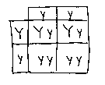
Image by Chernobyl Frog Dissections
Test Crosses
When an organism has the dominant phenotype, then its genotype can either be heterozygous or homozygous dominant (in other words, you can't tell by looking at it). This problem requires a test cross with a homozygous recessive organism (one who's genotype you can tell by looking at it).
Dihybrid Crosses
In a dihybrid cross, two traits are studied at one time.
Example:
A female guinea pig heterozygous for both fur color and coat texture is crossed with a male that has light fur color and is heterozygous for coat texture. Dark fur color is dominant (D) and light fur (d) is recessive. Rough coat texture (R) is dominant while smooth coat (r) is recessive. Find the possible genotypes of the offspring.
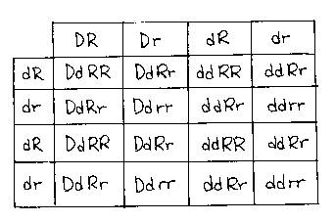
Image by Chernobyl Frog Dissections
Single Dominance
For single dominant traits you either have the allele or you don't. Examples of single dominant traits are ear attachment, tongue rolling, and PTC tasting.
Incomplete Dominance
Sometimes alleles are not dominant or recessive. Instead, in incomplete dominance, when two different alleles are combined the resulting expression is somewhere between the two.
Example:
Snapdragons show incomplete dominance. A red snapdragon (r) is crossed with a white flower (w). What are the possible genotypes of their offspring?
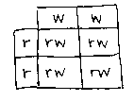
Image by Chernobyl Frog Dissections
Multiple Alleles
Some traits are coded for by more than two alleles.
Example:
In humans, there are four types of blood: type A, type B, type AB, and type O. The alleles A and B are codominant to each other and the O allele is recessive to both A and B. In the 1950s a young woman sued Charlie Chaplin for parental support of her illegitimate child. Charlie Chaplin's blood type was on record as type AB (ab). The mother of the child had type A (ao) and her son had type O blood (oo). Based on blood type, could the child have been Charlie Chaplin's?
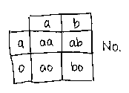
Image by Chernobyl Frog Dissections
Epistasis
Epistasis occurs when one gene affects the phenotypic expression of a second gene. For example, in mice there is a gene that codes for the presence or absence of pigmentation in fur. A second gene codes for the color of the fur. If the first gene codes for the absence of pigmentation, the mouse will have white fur regardless of the color the second gene codes for.
Pleiotropy
Pleiotropy occurs when a gene has more than one phenotypic expression. For example, in sickle cell anemia the gene that codes for hemoglobin is defective. Not only is the body unable to produce hemoglobin, but the shape of the red blood cells are affected as well.
Polygenic Inheritance
In polygenic inheritance there is more than one gene responsible for a trait. This usually results in continuous variation. In humans, for example, height is a result of the involvement of more than one gene.
Linked Genes
Linked genes are on the same chromosome and cannot segregate independently since they are physically connected. The farther away they are from each other on the chromosome, the more likely crossing-over can occur.
Sex-Linked Inheritance
In humans, sex is determined by the twenty-third pair of chromosomes known as the sex chromosomes. If at conception you have two X-shaped (XX) chromosomes you are destined to be a female. If you have an X and a Y-shaped chromosome (XY) you are destined to be male. Since the X and the Y chromosomes differ in the information they carry, any gene found on the X chromosome is referred to as a sex-linked gene. Women will have two alleles for sex-linked genes while men will only have one.
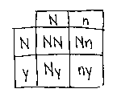
Example:
Hemophilia is a sex-linked trait. A person with hemophilia is lacking certain proteins that are necessary for normal blood clotting. Since hemophilia is a recessive trait, use N for normal and n for hemophilia. A woman who is heterozygous for hemophilia (a carrier) marries a normal man. What are the possible genotypes of their offspring?

Image by Chernobyl Frog Dissections

Sex-linked inheritance can also be examined through a pedigree chart.
Example:
Examine the following pedigree chart of colorblindness. In humans, color blindness is caused by a recessive sex-linked allele. On the diagram, label the genotypes of the individuals.
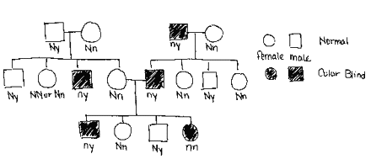
Image by Chernobyl Frog Dissections

X-Inactivation
In x-inactivation one X chromosome does not uncoil into a chromatin. This chromosome is referred to as a Barr body. Because it does not uncoil, none of the genes on the Barr body are active. Thus the female only has one set of working alleles.
Nondisjunction
Nondisjunction occurs when homologous chromosome pairs do no separate in meiosis. This results in one gamete receiving an extra chromosome. Examples of nondisjunction include Down syndrome (extra twenty-first chromosome) and Turner syndrome (females missing one X chromosome).
Human Genetic Defects
Genetic defects can be the result of recessive alleles or chromosomal abnormalities. Nondisjunction is an example of a chromosomal abnormality. Deletion (where portions of chromosomes are deleted), duplication (where portions of chromosomes are duplicated), translocation (where portions are moved to another chromosome), and inversion (where portions are arranged in reverse orientation on the same chromosome) are all examples of chromosomal abnormalities.
MOLECULAR GENETICS
Experiments
Griffith's Experiment
Griffith determined that there was a transforming factor or a chemical responsible for change in the genetic makeup of an organism. In his experiment he had a strain of smooth, virulent bacteria and a strain of rough, non-virulent bacteria. As his control, he injected a mouse with the virulent strain -- it died. He injected another mouse with the non-virulent strain -- it lived. Then he took the virulent strain and used heat to kill it. He then injected a mouse with the killed virulent strain -- it lived. He injected another mouse with a killed virulent strain that had been mixed with a non-virulent strain -- it died. He concluded that something caused the genetic makeup of the non-virulent bacteria to change into something virulent.
Hershey-Chase Experiment
Hershey and Chase determined that it was DNA that controlled the cell's activities. In their experiment, they labeled a bacteriophage with radioactive sulfur (in the protein coat) and radioactive phosphorus (in the DNA). They then mixed the phage in with other bacteria and waited for infection to occur. Then, they scanned the bacteria for radioactive elements. Hershey and Chase discovered that the radioactive sulfur was discarded by the phages outside of the bacteria cells while the radioactive phosphorus was inside the infected bacterial cells. This led them to conclude that DNA that was the genetic material.
Structure of DNA
Watson and Crick determined that DNA is a polymer of nucleotides arranged in a double helix. Each nucleotide is composed of a phosphate group, a sugar (deoxyribose), and a base. There are a total of four bases: adenine, thymine, cytosine, and guanine. Adenine and guanine are purines while cytosine and thymine are pyrimidines. Base-pairing occurs between adenine and thymine and between guanine and cytosine.
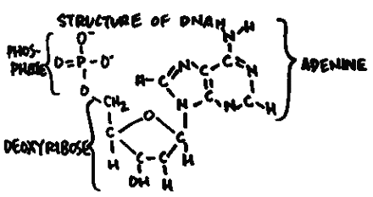
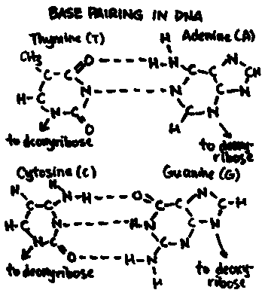
Image by Chernobyl Frog Dissections
Additionally, a strand of DNA has a 5' end and a 3' end (determined by the attachment of the phosphate to deoxyribose). In the double helix, each strand of DNA runs antiparallel (in the opposite direction) to the other so that the 5' end on one strand is across from the 3' end of the other.
Structure of RNA
RNA is a polymer of nucleotides. Unlike DNA, however, RNA is single-stranded. Also, the base thymine is replaced by the base uracil and the sugar ribose is used instead of deoxyribose.
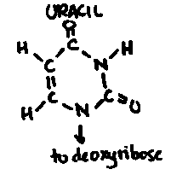
There are three kinds of RNA.
- Messenger RNA (mRNA) carries a copy of the DNA code to the ribosomes during protein sythesis.
- Transfer RNA (tRNA) transports amino acids (used to form proteins) to their proper place on the mRNA template.
- Ribosomal RNA (rRNA) are the building blocks of ribosomes. They are created in the nucleolus.
DNA Replication
- Promoter proteins are produced and bind to DNA at several sites.
- Helicases attach to promoter proteins and break the hydrogen bonds linking the bases together to open the helix up.
- RNA polymerase reads the exposed nucleotides and produces an RNA primer (approximately 10 nucleotides in length).
- DNA polymerase replicates the DNA (base-pairing) forming the new strand in the 5' to 3' direction.
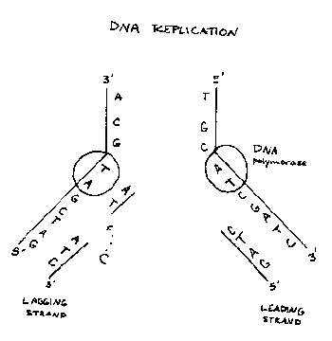
- Because DNA polymerase only reads in the 3' to 5' direction, and forms the new strand in the opposite direction, there is a directional problem. Therefore one molecule of DNA produces a continuous leading strand in one direction. On the lagging strand, new primers have to form at many sites and the DNA is broken up into many small fragments called Okazaki fragments.
- The process of DNA replication occurs at many sites, called replication bubbles, along the entire DNA strand.
- When DNA polymerase reaches the 5' end of the RNA primer, it is released and other enzymes remove the RNA primers and replace them with the proper nucleotides.
- DNA ligase joins together all of the large leading fragments and the many small Okazaki fragments.
- DNA polymerase also checks and corrects any mistakes in base pairing.
- Topoisomerases prevent kinks as the parent DNA is unzipped.

Mutations
Mistakes in base-pairing are corrected by DNA polymerase and other mismatch repair enzymes.
Radiation and various reactive chemicals can cause thymine dimers where adjacent nucleotides bind to each other instead of to the complimentary strand. Such errors are usually fixed by splicing out the affected nucleotides and replacing them (excision repair).
A mutation is a DNA error that is not repaired. Some mutations include using an incorrect nucleotide (substitution), deleting a nucleotide (deletion), and adding a nucleotide (insertion). When insertion occurs, all the subsequent nucleotides are misplaced causing a frameshift mutation.
Protein Synthesis
Protein synthesis is divided into two phases: transcription and translation.
In transcription, RNA polymerase unzips DNA and reads it in the 3' to 5' direction. Free RNA nucleotides are base paired with the exposed DNA nucleotides and assembled into mRNA. The mRNA then leaves the nucleus and moves to the ribosomes in the cytoplasm. Transcription ends and translation begins.

Translation has four stages.
- In the amino acid activation stage amino acids are attached to the appropriate tRNA molecules. A molecule of ATP is used to activate the tRNA.
- In the initiation stage the ribosome moves along the mRNA strand until it reaches the code for formyl methione (AUG).
- In the elongation stage the tRNA matches its anti-codon (three nucleotides) with the mRNA codon (three nucleotides). The amino acid on the previous tRNA is transferred to the newly arrived tRNA and the empty tRNA leaves. This is repeated over and over as the ribosome moves along the mRNA strand.
- In the termination stage a nonsense code is reached and the protein is released.
The Operon Theory
All enzymes are made of protein, all proteins are made of amino acids, and all amino acids have a DNA codon. Basically, DNA controls RNA which controls the production of proteins.
In 1961, François Jacob and Jacques Monod proposed the Operon Theory to explain how cells control the production of enzymes.
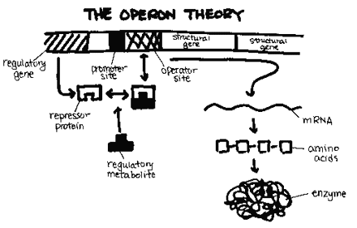
The following is a list of the components of the operon.
- The regulatory gene codes for the repressor protein.
- The promoter site is the attachment site for RNA polymerates.
- The operator site is the attachment site for the repressor protein.
- The structural genes code for the proteins.
- The repressor protein is different for each operon and is custom fit to the regulatory metabolite. Whether or not the repressor protein can bind to the operator site is determined by the type of operon.
- The regulatory metabolite is either the product of the reaction or the reactant depending on the type of operon.
- The messenger RNA.
- The final enzyme.
There are two kinds of operons: repressible and inducible.
- In the repressible operon, the product is the regulatory metabolite. When the concentration of the product increases, the product binds to the repressor protein allowing the repressor protein to bind to the operator site -- shutting the operon down.
- In the inducible operon, the reactant is the regulatory metabolite. When the concentration of the reactant increases, the reactant binds to the repressor protein removing the repressor protein from the operator site -- turning the system on.
DNA Organization
- There are several steps involved to get DNA into the form of a chromosome.
- First, DNA is twisted into a double helix.
- Second, the DNA double helix is wrapped around small proteins called histones to form nucleosomes.
- Third, the nucleosomes are arranged into looped domains.
- Finally, the looped domains are condensed into chromosomes.
Recombinant DNA
- Recombinant DNA is DNA that contains segments or genes from different sources. These segments are spliced together to form the recombinant DNA.
- Recombinant DNA technology uses restriction enzymes that cut the DNA after a certain sequence of nucleotides. The staggered cut is referred to as a sticky end. The sticky ends are then reintegrated into a DNA strand by the enzyme ligase.

EVOLUTION
Early Evolutionists
George-Louis Leclerc de Buffon (1707-1788) was among the first to propose that the species on Earth in the present were different from those long ago, although he still believed in creation.
James Hutton (1726-1797) was a geologist who proposed that the Earth was created through slow and gradual processes.
William Smith (1769-1839) was an English surveyor who studied the distribution of fossils in various strata or layers. He found certain types of fossils always appeared in the same strata.
Jean Baptiste Lamarck (1744-1829) was the first to propose that species change with time. His theory had three important ideas:
- Use and disuse referred to how body parts of organisms grow stronger with use and atrophy with disuse.
- Inheritance of acquired characteristics incorrectly described how things like muscle mass could be passed onto offspring.
- Natural transformation of species incorrectly described how species split into different species instead of going extinct.
Darwin's Theory
There are four main tenets to Darwin's Theory:
- Like begets like with variations within the offspring.
- More offspring are produced than can survive.
- Individuals in a population vary.
- Survival of the fittest. Nature selects those varieties best fit for survival.
In time, these changes accumulate to form new species.
Microevolution and Macroevolution
Microevolution describes how populations change from generation to generation and how new species originate.
Macroevolution describes the patterns in groups of organism over long periods of time. Phylogeny, the relationship between species and groups of species, is involved. There are two distinct theories of macroevolution:
- Phyletic gradualism argues that evolution occurs through the accumulation of small changes in organisms.
- Punctuated equilibrium argues that evolution occurs in bursts. Long periods of little speciation are punctuated with short periods of rapid evolution.
Evidence of Evolution
- The fossil record has revealed the extinction of certain species, the beginning of new species, and the evolution of other species.
- Biogeography has revealed that organisms in similar environments around the world tend to acquire the same adaptations for their survival. There may be no rabbits in Australia, but the Australian wallaby resembles rabbits in many ways.
- Embryology has revealed that there are similar stages in development among related species. Most notable is the fact that gill slits and tails are found in fish, chicken, pig, and human embryos.
- Comparative anatomy also supports the theory of evolution. Homologous structures in the forelimbs of various vertebrates support the concept of a common ancestor. Analogous structures in organisms that live in similar environments (like fins whales and fish) support the concept that the environment affects the development of organisms.
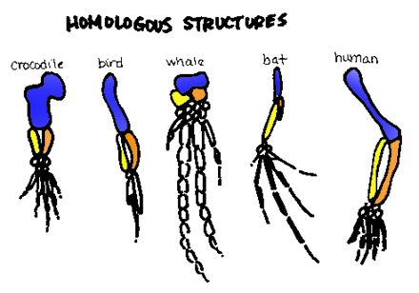
Sources of Variation
Variations in the genetic makeup of populations is what drives evolution.
Random mutations are the key to the creation of new alleles. All other methods merely rearrange the existing alleles in the gene pool.
Sexual reproduction also facilitates variation in populations of organisms. Crossing-over, independent assortment of homologues, and the random joining of gametes are examples processes that promote variation.
Diploidy, the presence of two copies of each chromosome in a cell, also promotes variation.
Outbreeding, or mating with unrelated partners, increases the possibility of different combinations of alleles.
Balanced polymorphism encourages the existence of more than one allele for a certain gene because of the survival benefits of both alleles. In heterozygote advantage, the heterozygote with both the dominant and the recessive allele has a better chance of survival than both the homozygous dominant and homozygous recessive variaties. Hybrid vigor describes the superior quality of offspring between two inbred strains of plants.
Genetic (Hardy-Weinberg) Equilibrium
Genetic (Hardy-Weinberg) Equilibrium occurs in a theoretical non-evolving population. In order for this to occur several assumptions are made:
- No natural selection is occuring.
- No mutations are occuring.
- No gene flow is occuring.
- No genetic drift is occuring.
- Mating is random.

In Hardy-Weinberg, the allele frequencies are represented by the letter p and q. The frequencies of both alleles (p + q) add up to one hundred percent. Diploid organisms each have two alleles. So the probability that both alleles are p is represented by p². The probability that both alleles are q is represented by q². The probability that the organism is heterozygous is 2pq.
Agents of Change
In a nutshell, everything not operating under Hardy-Weinberg.
- Natural selection is the increase or decrease in allele frequency due to its survival benefit for the organism. Natural selection is discussed thoroughly in the next section.
- Mutations are random changes in an organisms genetic code that may lead to the formation of a new allele. Most mutations, however, are harmful.
- Gene flow is the addition or reduction of alleles when individuals enter and leave the population.
- Genetic drift is the random increase or decrease of the occurrence of an allele in a population. Genetic drift is the most evident in small populations. The founder effect is a type of genetic drift that occurs when the organisms in the founding group have different allele frequencies from the population they left. The resulting offspring will reflect the genetic makeup of the founders. A population bottleneck is another type of genetic drift that occurs when the population undergoes a dramatic decrease in size. This may lead to the removal of some alleles from the gene pool if all the carriers of that allele were wiped out.
- Nonrandom mating occurs when individuals choose mates based on certain traits. Sexual selection is when females choose males based on their appearance or their competence in some other area. Nonrandom mating also occurs when individuals choose mates from only nearby individuals. Inbreeding is when individuals mate with relatives.

Natural Selection
Natural selection is the ability of an organism to survive to reproduce in their environment based on their genetic makeup. Some alleles will give the organism a higher probability of survival than others. Superior traits that aid the organism in its struggle to survive are often referred to as adaptations. There are five main forms of selection:
- Stabilizing selection eliminates individuals with extreme or unusual traits.
- Directional selection favors traits at one extreme of the range of traits.
- Disruptive selection occurs when the environment favors extreme traits over common traits.
- Sexual selection is the selection of a mate based on a trait. In male competition the male that wins the contests of strength, agility, etc. mates with the female. In female choice the female mates with the male that she prefers based on certain characteristics.
- Artificial selection is a form of selection carried out by humans.
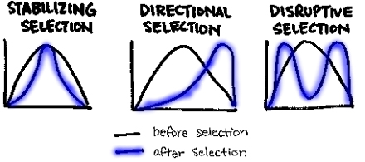
Speciation
A species is a group of animals capable of interbreeding and producing fertile offspring. In speciation a group of organisms has changed so much that they are no longer able to mate with members of the population in which they were once a member. There are three main forms of speciation:
- Allopatric speciation occurs when a population is divided by a geographic barrier. With no interbreeding occurring between the members of the separated populations, the genetic makeup of the two groups gradually changes through successive generations so that if the barrier were to be removed they would no longer be able to reproduce together.
- Sympatric speciation occurs when a new species is formed without geographic isolation. Balanced polymorphism is an example of sympatric speciation that occurs when members of a population only interbreed with other members that share a certain allele (i.e. fur color). Eventually, the gene pool is altered to the point that a new species is formed. Polyploidy is the possession of more than two sets of chromosomes and is common in plants. Hybridization occurs when members of two different species have offspring that become different species.
- Adaptive radiation is the sudden evolution of many species from a single ancestor.

Reproductive Isolation
There are two main types of reproductive isolation.
Pre-mating reproductive isolation prevents fertilization from occurring.
- Habitat isolation occurs when the organisms do not encounter each other.
- Temporal isolation occurs when the organisms mate at different times of the day.
- Behavioral isolation occurs when the organisms refuse to mate because of different courtship rituals, etc.
- Mechanical isolation occurs when the male and female genitalia are physically incompatible.
- Gametic isolation occurs when the male gametes cannot survive in the mating environment long enough to fertilize the female.
Post-mating reproductive isolation prevents the formation of fertile offspring.
- Hybrid inviability occurs when the zygote fails to develop properly and dies.
- Hybrid sterility occurs when resulting offspring are unable to reproduce as adults.
- Hybrid breakdown occurs when the hybrids produce offspring that have limited reproductive capacity.
Patterns of Evolution
There are four common patterns of evolution:
- Divergent evolution describes two or more species that evolved from a common ancestor.
- Convergent evolution describes two or more unrelated species that have adopted similar adaptations to their environment.
- Parallel evolution describes two or more species that have continued to evolve similar characteristics even after their divergence from a common ancestor.
- Coevolution describes the evolution of one species in response to the evolution of another. Coevolution usually occurs in a predator-prey relationship.

TAXONOMY
Taxonomy is the classification of organisms. The most common system in use today is the Five Kingdoms system of classification. In this system all organisms are divided into five kingdoms: Monera (Prokaryota), Protista, Fungi, Plantae, and Animalia. Organisms in each kingdom are divided into phyla. In each phylum, organisms are separated into classes. In each class, organisms are segregated into orders. In each order, organisms are divided into families. In each family, organisms are separated by genus. And finally, in each genus organisms are divided into species. Just remember that King Philip Come Over From Glorious Scotland.
Kingdom Monera
- All organisms in the Kingdom Monera are prokaryotes. They lack nuclei and organelles and most of their cell walls are made of peptidoglycan (the exceptions are the archaebacteria). Most utilize flagella for movement.
- Digestion is extracellular (outside the cell) and nutrients are absorbed into the cell. Many prokaryotes are organized by how the metabolize resources. Autotrophs manufacture their own organic compounds. Heterotrophs obtain their energy by feeding on other organic substances. Saprophytes, a special kind of heterotroph, obtain energy by feeding on decaying matter. Some bacteria live in symbiotic relationships with other organisms. In parasitism, harm is caused to the host. In commensalism, one organism benefits while the other is unaffected. In mutualism, both organisms benefit.
- Circulation and digestion in Kingdom Monera is accomplished through diffusion.
- Respiration in these organisms vary. In obligate aerobes, the prokaryotes must have oxygen to live. In obligate anaerobes, the organisms cannot survive in the presence of oxygen. And in facultative anaerobes they can survive with or without oxygen.
- Most organisms in the Kingdom Monera reproduce through binary fission (asexual) or conjugation (sexual).
- Recently, biologists have identified two distinct groups within Monera.
- The archaebacteria have cell walls that lack peptidoglycan, cell membranes that utilize different lipids, and ribosomes similar to those found in eukaryotes.
- The eubacteria ("true bacteria") are characterized by how they metabolize resources, their means of motility, and their shape. The three basic shapes are cocci (spherical), bacillus (rod shaped), and spirillum (spirals).
Kingdom Protista
Protists are grouped according to whether they are animal-like, plant-like, or fungus-like.
Animal-like protists are called protozoans. They are unicellular and parasitic. Digestion in protozoans is intracellular. Circulation, respiration, and excretion are accomplished through diffusion. Most reproduce through binary fission (asexual) although some utilize conjugation (sexual).
Plant-like protists contain chlorophyll. They are both unicellular and multicellular (although multicellular forms have no organs or tissues).
- Members of Phylum Chlorophyta are the most modern and have chlorophyll a, b, and carotene.
- Members of Phylum Chrysophyta are unicellular, golden algae.
- Members of Phylum Phyrrophyta are unicelluar, fire algae with flagella.
- Members of Phylum Phaeophyta are multicellular, brown algae.
- Members of Phylum Rhodophyta are multicellular, red algae.
- Members of Phylum Euglenophyta live in freshwater.
Fungus-like protists are divided into three groups: mxyomycota ("plasmodial slime molds"), acrasiomycota ("cellular slime molds"), and oomycetes ("mildews and water molds"). Circulation, respiration, and excretion are all accomplished through diffusion. Reproduction can be asexual through fragmentation and the production of spores or sexual through conjugation and alternation of generations.

Kingdom Fungi
In general, fungi are multicellular, parasitic or saprophytic, and have cell walls made of chitin. Digestion is extracellular. Rhizoids secrete enzymes and reabsorb the digested nutrients. Circulation, respiration, and excretion occur through diffusion. Reproduction can be asexual through spores or sexual where strains of fungi meet.

Kingdom Plantae
In general, all plants have chlorophyll, cell walls of cellulose, and tissues and organs. Biologists have theorized that plants evolved from algae since both plants and algae have chloroplasts with chlorophyll, cell walls of cellulose, glucose stored as starch, and alternation of generations.
Plants are classified in the following divisions:
- Division Bryophyta- plants are primitive and lack vascular tissue and true roots. Examples include mosses and liverworts.
- Super Division Tracheophyta- plants are more advanced and contain vascular tissue.
- Division Pterophyta- plants reproduce by spores and grow from underground stems. Example include ferns and horsetails.
- Division Coniferophyta- plants produce naked seeds in cones and soft wood. Many are evergreens. Examples include redwoods, pines, cypress, and junipers.
- Division Anthophyta- plants are the most advanced and produce flowers. Class monocotyldonae plants have seeds that contain one cotyledon, leaves with parallel veins, flower parts in multiples of three, no cambium, and scattered vascular bundles in the stem. Class dicotyledonae plants have seeds that contain two cotyledons, leaves with netted veins, flower parts in multiples of four and five, cambium, and vascular bundles in a cylinder.

Kingdom Animalia
- Animals are heterotrophic, multicellular organisms with organs or tissues. Most are mobile or have a mobile life stage. All have a larval or embryonic stage of development.
- Animals also exhibit different kinds of symmetry: asymmetry, spherical, radial, and bilateral.
- Finally, animals can be invertebrates (no backbone) or vertebrates (with backbone).

PLANT BIOLOGY

Plant Tissues
Plant tissues are grouped according to their function.
Protective tissues protect the plant from harm. The epidermis of the plant secretes the cuticle -- a waxy layer for protection. In woody plants, the cork forms the bark.
Storage tissues store the plants food and water supplies. Parenchyma is a thin walled tissue in the leaves. Collenchyma is thick walled support tissue. Schlerenchyma is very thick support tissue that surrounds the veins of leaves, stems, and roots.
Vascular tissues are responsible for the transport of water and nutrients to different parts of the plant. Xylem is made of dead cells and conducts water and dissolved minerals. Phloem is composed of dead sieve tube cells and living companion cells. It transports organic material.
All of the plants growth occurs in the growth tissues. Meristem is responsible for primary growth and is found at the tips of roots and stems. If cut off, growth will cease. Cambium is responsible for secondary growth and is only found in dicots and conifers between the xylem and phloem.
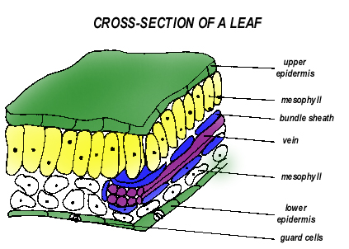
Structure of Leaves
The functions of the leaf include trapping light for photosynthesis, controlling transpiration, and releasing oxygen and storing carbon dioxide.
Structurally, the leaf provides a high surface area to volume ratio. The internal layers of the leaf (from top to bottom) include the cuticle, the upper epidermis, the mesophyll, and the lower epidermis. Veins and bundle sheath cells are located in the mesophyll. Stomates, which regulate the flow of carbon dioxide and oxygen into and out of the leaf, are located in the lower epidermis.
Structure of Stems
The functions of the stem include conducting materials between the roots and the leaves, supporting the plant, and placing the leaves in light.
External stem structures include buds, bud scale scars, lenticels, and leaf scars. Internal stem structure include pith, xylem, and phloem. In monocots, the vascular tissue is scattered throughout the stem. In dicots, the vascular tissue is arranged in a ring.
Transport of Water
After entering the plant at the root hair, there are two routes that water can take to reach the center of the root. In the apoplastic route, water moves through plant cell walls without ever entering the individual cells. In the symplastic route, water moves through the plant cells by the way of the plasmodesmata.
There are three mechanisms that describe how water gets from the roots to the leaves.
- Capillary action involves the rise of liquids in narrow tubes. The liquids are attracted to the walls of the tube. This attraction, called adhesion, pulls liquids up the tube. Capillary action, however, is not strong enough to account for much of the movement of water to the leaves.
- Root pressure is another mechanism for moving water up the xylem. In this theory, water entering the root exerts a pressure on the water already in the xylem above it pushing it further upwards. Root pressure, however, also does not account for moving water large distances.
- Most water movement through the xylem is accomplished through the process described in the cohesion-tension theory. Water, due to its polarity, forms a chain from the leaves to the roots. As water evaporates from the leaves in transpiration, the chain is drawn upwards.
Transport of Sugars
- Translocation, the movement of carbohydrates from their site of production to where they are needed, is accomplished through the pressure-flow theory. In this theory, sugar enters the sieve tube cells of the phloem, reducing the concentration of water inside. This causes water to osmose into the sieve tube in an attempt to balance the concentration. Meanwhile, where cells are using sugar, the concentration of sugar is falling. This leads to a concentration gradient from the leaves (where sugar production occurs) to the site where sugar is needed. Because the sieve tube cell walls are rigid, the entry of excess water causes pressure to rise. This causes the water in the phloem by the leaves to push away in an attempt to equalize the pressure -- at the same time carrying sugar with it.
Plant Reproduction
- Plants can reproduce asexually or sexually.
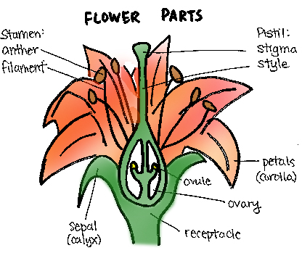
- To reproduce asexually, plants use rhizoids, fragmentation, or budding. Strawberries, crab grass, and Bermuda grass are examples of plants that reproduce with rhizoids. The creeping Charlie is an example of a plant that reproduces through fragmentation. The banana is an example of a plant that reproduces through budding.
- Sexual reproduction in plants involves male and female plant organs. The female structures invovled in sexual reproduction are the stigma, the style and the ovary. The stigma is the sticky portion of the pistil that captures pollen. The style is long and slender and supports the stigma. The ovary is composed of one or more ovules and is responsible for housing the eggs. The male structures involved in sexual reproduction are the filament and the anther. The filament supports the anther which is responsible for storing and producing pollen. Pollination is the transfer of pollen from an anther to a stigma. Wind, water, insects, birds, and small mammals all aid in the pollination of plants. After pollination, one nuclei of the pollen grain forms a tube down through the style to the micropyle of the ovary. The second nuclei travels down the tube and splits into two sperm nuclei that fertilize the egg and combine with polar bodies to form the endosperm (stored fruit).

ANIMAL BIOLOGY
Phylum Porifera
Characteristics:
The simplest of all animals with no formal digestive, circulatory, or nervous systems. They display radial symmetry and assymmetry. They have two layers: an endoderm and an ectoderm. Most are salt water sponges.
Classification
The four classes are grouped according to skeletal structure.

Protection
Some members are poisonous or they taste bad.

Movement
Adults are sessile (they don't move) while larvae are free swimming.

Feeding & Digestion
Porifera are filter feeders (they filter food out of the water). They have intracellular digestion.

Circulation
Circulation in porifera is mainly carried out through diffusion.

Reproduction
Reproduction can be asexual or sexual. Asexual forms include fragmentation, budding, and gemmules (amoebocytic sporulation). Since most sponges are hermaphroditic, sexual reproduction is carried out by releasing sperm into the current. Fertilization is internal and occurs when sponges filter the sperm from the current.

Phylum Cnidaria (coelenterate)
Characteristics:
Members of this phylum live in both fresh and salt water, have tissues and a simple nervous system, and have stinging cells called nematocysts. They display radial symmetry and have two embryonic cell layers (the epidermis and the gastrodermis) separated by jellylike mesoglea.
Classification
The three classes are grouped according to body plan. Members of the class Hydrozoa have both the polyp and medusa stage in their life cycle. Examples include the Portuguese man-o-war. Members of the class Anthozoa have only the polyp stage in their life cycle. They are slightly more complex than hydrozoans. Examples include sea anemones. Members of the class Scyphozoa have only the medusa stage in their life cycle. They are the most large and complex members of this phylum. Examples include the common jellyfish.
Protection
Members of this phylum use nematocysts for protection.
Movement
Most adult cnidarians are free floating. In the larval stage, members are free swimming.

Feeding & Digestion
Cnidarians employ stinging cells called cnidocytes to catch food. There is both extracellular and intracellular digestion.
Circulation
Circulation is mainly accomplished through diffusion.
Excretion
Excretion is accomplished through diffusion.
Respiration
Respiration is accomplished through diffusion.
Nervous System
Cnidarians posses simple muscles and nerves. The statocyst is a gravitational sensory organ. The ocellus is a simple photoreceptor organ.
Reproduction
Asexual reproduction occurs through budding. Sexual reproduction occurs in the medusa stage.
Phylum Platyhelminthes
Characteristics
Members of phylum Platyhelminthes have a flattened, bilaterally symmetrical body. They have three embryonic layers (triploblastic): the endoderm, the mesoderm, and the ectoderm. Flat worms have no other body cavity than the digestive cavity (acoelomates).
Classification
Members of the class Turbellaria have bodies covered with cilia and are free living. Members of the class Trematoda are parasites with a thick cuticle instead of cilia. Members of the class Cestoda are also parasites with a thick cuticle.
Protection
Parasitic flat worms have a thick cuticle for protection. Free living flat worms rely on camouflage.
Movement
Turbellians use cilia to move while parasitic worms rely on the host's circulation.
Feeding & Digestion
Flat worms have one digestive opening that branches to all parts of the body. Turbellarians have a muscular pharynx to up food. Parasitic classes rely on the host for digestion.
Circulation
Circulation occurs through diffusion.
Excretion
Excretion occurs through flame cells.
Respiration
Respiration occurs through diffusion.
Nervous System
Platyhelminthes have a simple brain called a ganglion and a ventral nerve cord.
Reproduction
Asexual reproduction occurs through fragmentation or fission. Since the flat worms are hermaphrodites, sexual reproduction occurs through the exchange of sperm.
Phylum Nematoda
Members of the phylum Nematoda have smooth, round bodies. They were the first to evolve two digestive openings: a mouth and an anus. Although most are free living, many are parasitic. Nematodes are pseudocoelomates.
Phylum Annelida
Characteristics
Annelids were the first animals to evolve a complete coelom (an internal body cavity lined with epithelial tissue). They are segmented and have most comlete body systems.
Classification
Members of the class Polychaeta are marine worms. Members of the class Oligocheata are earthworms. Members of the class Hirudinea are parasitic worms.
Movement
Annelids have various muscle groups and simple appendages. They use setae and parapodia for movement.
Feeding & Digestion
Marine worms are filter feeders or scavengers. Earthworms squeeze organic material out of the earth. The digestive systems for all three classes are well-developed and use division of labor.
Circulation
Annelids are the first to have a closed system of blood vessels -- making pumping more efficient.
Excretion
Annelids have one pair of nephridia per segment for excretion.
Respiration
Respiration occurs through diffusion.
Nervous System
Members of this phylum have a simple brain located in the anterior end with ganglia in every segment. They can sense light, moisture, and chemicals.
Reproduction
Since annelids are hermaphroditic, sexual reproduction occurs through the exchange of sperm packets.
Phylum Mollusca
Characteristics
Mollusks have three distinct body zones. The head-foot contains both sensory and movement organs. The visceral mass includes the digestive, excretory, and reproduction organs. The mantle secretes the shell.
Classification
Mollusks are classfied according to the number of shells or foot shape. Members of the class Gastropoda ("univalves") have one shell and demonstrate torsion (a 180 degree counterclockwise twist of the gut). An example of a gastropod is a snail. Members of the class Pelecypoda have two hinged shells and a muscular, hatchet-like foot. An example of a pelecypod is a clam. Members of the class Cephalopoda have a muscular foot divided into multiple, arm-like tentacles. An example of a cephalopod is an octopus.
Protection
Mollusks are protected by a calcium carbonate shell, ink, and toxins.
Movement
Gastropods secrete a slime trail and their muscular foot contracts to slide over it. Pelecypods are mainly sessile (they don't move). Both pelecypods and cephalopods can use jet propulsion (think squid).
Feeding & Digestion
Pelecypods are mainly filter feeders. Cephalopods are active predators. Gastropods have a sharp radula for drilling through shells. Digestion can occur in a ciliated tract or intracellularly.
Circulation
Most have an open circulatory system (blood is not restricted to circulating within blood vessels). Cephalopods have a closed circulatory system.
Excretion
Excretion occurs in nephridia.
Respiration
Mollusks use external gills for respiration. Diffusion also occurs through the moist skin of the mollusks.
Nervous System
Mollusks have a complex brain, nerves, and a compound eye.

Reproduction
Reproduction occurs sexually with separate sexes. Fertilization is external.
Phylum Echinodermata
Characteristics
All echinoderms are marine organisms. In the larval stage, most echinoderms are bilaterally symmetrical. Most adults are radially symmetrical. They have a ventral mouth, an internal skeleton of calcium carbonate plates, and a water vascular system consisting of tube feet, radial canals, and a ring canal for movement.
Classification
Members of the class Crinoidea include sea lilies and feather stars. Members of the class Stelleroidea include sea stars and brittle stars. Members of the class Echinoidea include sea urchins and sand dollars. Members of the class Holothuroidea include sea cucumbers.
Protection
Spinal extensions of the skeleton protect echinoderms.
Movement
The water vascular system of echinoderms is responsible for their movement and ability to clean to surfaces for long periods of time.
Feeding & Digestion
Urchins are herbivores (they eat plants), starfish are predators and scavengers, and other feed on detritus (waste).
Circulation
Echinoderms have an open circulatory system with cilia circulating the fluids through each arm.
Excretion
Amoeboid cells carry wastes out of the body.
Respiration
Gills on the skin exchange gases.
Nervous System
Echinoderms have a nerve ring around the central disc instead of a brain. Eyespots on the tips of arms sense light.
Reproduction
Echinoderms have the ability to regenerate new parts asexually. They also have separate sexes with sex organs in each arm. Sexual reproduction involves releasing gametes into the water (external fertilization).
Phylum Arthropoda
Characteristics
Arthropods have jointed appendages and an exoskeleton. The exoskeleton has three layers. The lipoprotein outer layer provides water proofing. The chitin middle layer provides hard protection. The flexible inner layer allows movement. Like the annelids, their bodies are segmented.
Classification
Members of the class Crustacea are all aquatic (except for the pill bug) and have gills. They have five pairs of legs and two body regions: the cephalothorax and the abdomen. Examples include lobsters, crabs, and barnacles. Members of the class Chilopoda have many body segments with one pair of legs per segment. An example of a chilopod is a centipede. Members of the class Diplopoda also have many body segments but they have two pairs of legs per segment. An example of a diplopod is a millipede. Members of the class Arachnida have no antennae and four pairs of legs. Their first appendages are poisonous pinchers called chelicerae. Examples include spiders, scorpions, and ticks. Members of the class Insecta have three pairs of legs and one or two pairs of wings. Their body is divided into three sections: the head, the thorax, and the abdomen.
Protection
Arthropods are protected by fast movement, an exoskeleton, pinchers, camouflage, and poison glands.
Movement
The fast movements of arthropods are the combined result of jointed appendages, a hard skeleton, and fast acting striated muscle.
Feeding & Digestion
Arthropods have very varied diets. Digestion is extracellular in the gut and there is a division of labor.
Circulation
Arthropods have an open circulatory system. They have a dorsal heart and arteries.
Excretion
Crustaceans excrete through nephridia or green glands. Others use a network of Malpigian tubes which collects liquid wastes in the gut. Wastes are crystallized and then excreted to reduce weight for flight.
Respiration
Crustaceans use gills. Insecta, chilopoda, and diplopoda use trachea and spiricles. Arachnids use book lungs.
Nervous System
Arthropods have a highly complex nervous system with a brain and a ventral nerve cord. They also have compound eyes, proprioceptors, touch receptors, chemoreceptors, and auditory receptors.
Reproduction
Most have separate sexes and internal fertilization. Most undergo some form of metamorphosis.

Phylum Chordata
General Characteristics
All chordates have a dorsal hollow nerve tube, a notochord, and pharyngeal gill slits. All vertebrates (members of a subphylum of chordata) have a backbone (spinal column) and a closed circulatory system.
Fish
Members of the class Agnatha are jawless fish. Examples include lampreys and hagfish. Members of the class Chondrichthyes have skeletons made of cartilage, placoid scales, and lack gill covers. Examples include sharks and rays. Members of the class Osteichthyes have skeletons made of bone, cycloid scales, gills covered with opercula, and a swim bladder (for floating). Fish have a two-chambered heart.
Amphibians
In general, amphibians have smooth, moist skin. The are ectothermic (cold blooded) and must return to water to breed. The members of the order Urodela have tails as adults while the members of the order Anura do not. Amphibians have a three-chambered heart. They have two lungs for respiration, but most respiration is accomplished through the skin and lining of the mouth. For excretion, amphibians use two kidneys.
Reptiles
Reptiles have bodies covered with scales and dry skin. They are also ectothermic. Unlike amphibians, however, reptiles are completely independent of water. The order Rhyncocephalia contains the most ancient species of reptile. In the order Chelonia the teeth are fused to form a beak and the body is enclosed in two shells. Members of the order Crocodilia have thick, leathery skin, large teeth, and a four-chambered heart. However, most other reptiles have three-chambered hearts. The order Squamata contains a two suborders: Sauria (lizards) and Serpentes (snakes).
Birds (class Aves)
Birds are characterized by feathers, wings, beaks, and hollow bones (for flight). They are classified according to living style, foot structure, and beak structure. They have a double circulatory system (veins and arteries) and a four-chambered heart. Both their excretory and digestive wastes are mixed and excreted together through the cloaca.
Mammals (class Mammalia)
Mammals are characterized by mammary glands (a gland that secretes milk for the young), extended parental care, body hair, and giving birth to live young. Monotremes include platypuses and echidnas. They have no true teeth and their legs are out to the side like reptiles. Marsupials include kangaroos and opossums. Their young finishes development in a pouch. Placentals comprise the largest group of mammals. They have an uterus for developing embryos and a placenta for nourishment of the young.

HUMAN BIOLOGY
INTRODUCTION AND OVERVIEW OF HUMAN BIOLOGY
Introduction

1. The human body begins to take shape during the earliest stages of embryonic development. While the embryo is a tiny hallow ball of dividing cells, it begins forming the tissues and organs that compose the human body. By the end of its third week, human embryo has bilateral symmetry and is developing vertebrate characteristics that will support an upright body.

2. The study of body structure, which includes size, shape, and composition, is called anatomy.

3. The study of how the body functions is called physiology.
Six Levels of Structural Organization

1. Chemical Level
a. the chemicals that make up the body may be divided into two major categories: inorganic and organic.
b. inorganic chemicals are usually simple molecules made of one or more elements other than carbon. examples: water, oxygen, carbon dioxide (an exception), and minerals such as iron, calcium, and sodium.
c. organic chemicals are often very complex and always contain the elements carbon and hydrogen. examples: carbohydrates, fats, proteins, and nucleic acids.
2. Cellular Level
a. the smallest living units of structure and function are cells.
b. cells are the smallest living subunits of a multicellular organism such as a human being.
c. there are many different types of cells; each is made of chemicals and carries out specific chemical reactions.
3. Tissue Level
a. a tissue is a group of cells with similar structure and function.
b. there are four groups of tissue.
c. epithelial tissue - cover or line body surfaces; some are capable of producing secretions with specific functions. the outer layer of the skin and sweat glands are examples of epithelial tissue.
d. connective tissue - connects and supports parts of the body; some transport or store materials. Blood, bone, and adipose tissue (fat) are examples.

e. muscle tissue - specialized for contraction, which brings about movement. Our skeleton muscles and the heart are examples.

f. nerve tissue - specialized to generate and transmit electrochemical impulses that regulate body functions. the brain and optic nerves are examples.

4. Organ Level
a. an organ is a group of two or more different types of tissues precisely arranged so as to accomplish specific functions and usually have recognizable shape.
b. heart, brain, kidneys, liver, lungs are examples.

5. Organ Systems (System Level)
  - an organ system is a group of organs that all contribute to a particular function.
  - examples are the circulatory, respiratory, and digestive systems.
c. each organ system carries out its own specific function, but for the organism to survive the organ systems must work together- this is called integration of organ system.

6. Organism Level
a. the most complex level.
b. all the organ systems of the body functioning with one another constitute the total organism - one living individual.

Principal Organ Systems of the Human Body
1. Integumentary System
a. the skin and structures derived from it, such as hair, nails, and sweat and oil glands.
b. is a barrier to pathogens and chemicals (protects the body), helps regulate body temperature, eliminates waste, helps synthesize vitamin d, and receives certain stimuli such as temperature, pressure, and pain.
2. Skeletal System
a. all the bones of the body (206), their associated cartilage, and the joints of the body.
b. bones support and protect the body, assist in body movement, they also house cells that produce blood cells, and they store minerals.
3. Muscular System
a. specifically refers to skeletal muscle tissue and tendons.
b. participates in bringing about movement, maintaining posture, and produces heat.
4. Circulatory and Cardiovascular System
a. the heart, blood and blood vessels.
b. transports oxygen and nutrients to tissues and removes waste.
5. Lymphatic System- sometimes included with the immune system or circulatory system because it works closely with both systems.
a. the lymph, lymphatic vessels, and structures or organs (spleen and lymph nodes) containing lymph tissue.
b. cleans and returns tissue fluid to the blood and destroys pathogens that enter the body.
6. Nervous System
a. the brain, spinal cord, nerves, and sense organs, such as the eye and ear.
b. interprets sensory information, regulates body functions such as movement by means of electrochemical impulses.
7. Endocrine System
a. all hormone producing glands and cells such as the pituitary gland, thyroid gland, and pancreas.
b. regulates body functions by means of hormones.
8. Respiratory System
a. the lungs and a series of associated passageways such as the pharynx (throat), larynx (voice box), trachea (windpipe), and bronchial tubes leading into and out of them.
b. exchange oxygen and carbon dioxide between the air and blood.

9. Digestive System
a. a long tube called the gastrointestinal (gi) tract and associated organs such as the salivary glands, liver, gallbladder, and pancreas.
b. breaks down and absorbs food for use by cells and eliminates solid and other waste.
10. Urinary and Excretory Systems
a. the kidneys, urinary bladder, and urethra that together produce, store, and eliminate urine.
b. removes waste products from the blood and regulates volume and ph of blood.
11. Immune System
a. the immune system consists of several organs, as well as white blood cells in the blood and lymph. includes the lymph nodes, spleen, lymph vessels, blood vessels, bone marrow, and white blood cells (lymphocytes).
b. provides protection against infection and disease.
12. Reproductive System
a. organs that produce, store, and transport reproductive cells (sperm and eggs).
b. produces eggs and sperm, in women, provides a site for the developing embryo-fetus.
Homeostasis

1. all of the above systems function together to help the human body to maintain homeostasis.
2. a person who is in good health is in a state of homeostasis.
3. homeostasis reflects the ability of the body to maintain relative stability and to function normally despite constant changes.
4. changes may be external or internal, and the body must respond appropriately.
5. as we continue to study the human body, keep in mind that the proper functioning of each organ and organ system has a role to perform in maintaining homeostasis.
6. the human body uses homeostasis mechanisms to maintain its stable internal environment. homeostasis mechanisms work much like a thermostat (negative feedback) that is sensitive to temperature and maintains a relative constant room temperature whether the room gets to hot or cold.

Body Cavities
1. many organs and organ systems in the human body are housed in compartments called body cavities
2. these cavities protect delicate internal organs from injuries and from the daily wear of walking, jumping, or running.
3. the body cavities also permit organs such as the lungs, the urinary bladder, and the stomach to expand and contract while remaining securely supported.
4. the human body has four main body cavities:
a. cranial cavity - encases the brain.
b. spinal cavity - extending from the cranial cavity to the base of the spine, surrounds the spinal cord.
c. the two main cavities in the trunk of the human body are separated by a wall of muscle called the diaphragm.
d. thoracic cavity - the upper compartment, contains the heart, the esophagus, and the organs of the respiratory system - the lungs, trachea, and bronchi.
e. abdominal cavity - the lower compartment, contains organs of the digestive, reproductive, and excretory systems.

Anatomical Terminology
- To communicate effectively with one another, researchers and clinicians have develop a set of terms to describe anatomy that have precise meaning. Use of these terms assumes the body in the anatomical position. This means that the body is standing erect, face forward with upper limbs at the sides and with the palms forward.

- Relative Position: terms of relative position describe the location of one body part with respect to another. They include the following:
1. superior - means that a body part is above another part or is closer to the head.
2. inferior - means that a body part is below another body part or toward the feet.
3. anterior – means toward the front.
4. ventral – also means toward the front
5. posterior – is the opposite of anterior; it means toward the back.
6. dorsal - also is the opposite of anterior; it means toward the back.
7. medial – relates to an imaginary midline dividing the body in equal right and left halves. sample: the nose is medial to the eyes.
8. lateral – means toward the side with respect to the imaginary midline. sample: the ears are lateral to the eyes.
9. proximal – describes a body part that is closer to a point of attachment or closer to the trunk of the body than another part. sample: the elbow is proximal to the wrist.
10. distal – is the opposite of proximal. it means that a particular body part is farther from the point of attachment or farther from the trunk of the body than another part. sample: the fingers are distal to the wrist.
11. superficial – means situated near the surface.
12. peripheral – also means outward or near the surface.
13. deep – describes parts that are more internal.
14. cortex - the outer layer of an organ
15. medulla - the inner portion of an organ.

